

Neo Modern


Neo Modern Exposed Bath & Shower Mixer
FFAS9088-100500BF0
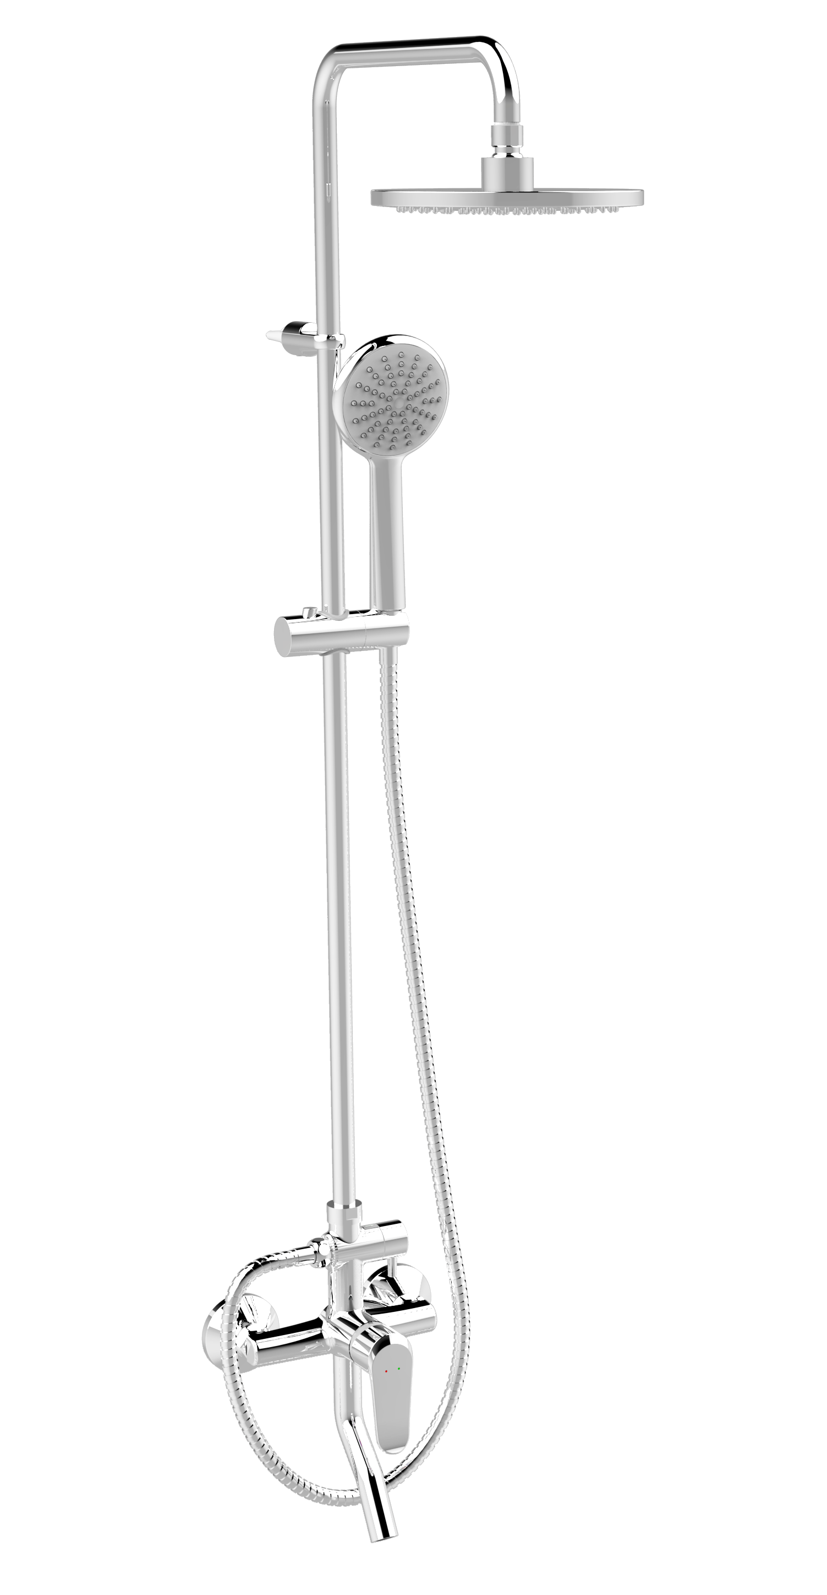

FEATURES

- A grade brass, strong and durable
- High quality ceramic valve for longer usage
- 3 way Ceramic diverter for longer usage
- Single function hand shower
- With φ200mm head shower
- With 1.5M Twist-free shower hose
- With adjustable shower Hanger
- With normal packaging
- Flow rate @ 0.1MPa: 5.9 L/min for hand shower
- Flow rate @ 0.1MPa: 5.9 L/min for shower head
- Flow rate @ 0.1MPa: 9.8 L/min for Spout

SPECIFICATIONS

Exposed bath & shower mixer
φ200mm Plastic Round Shower Head
2-handles (Mixer& Diverter)

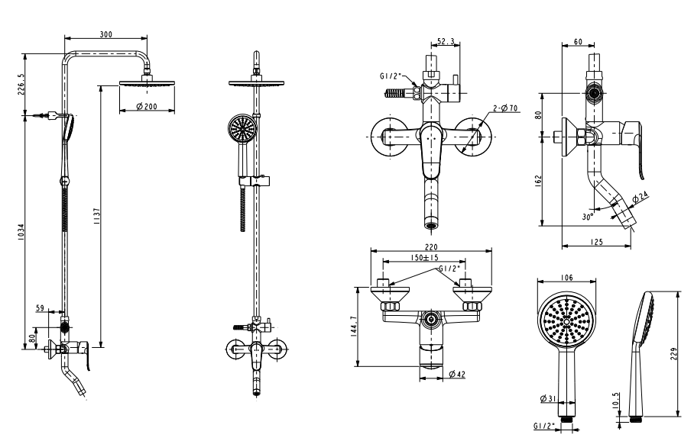
FINISHES AVAILABILITY
DIMENSIONAL DRAWING

Chrome (- CP)

AWARDS WON
N/A

SHIPPING WEIGHT
Product gross weight: 5 kg/set
Product net weight: 4.65 kg/set

STANDARDS CRITERIA
GB 18145-2014
GBT 23447-2009

This document is the property of American Standard. It can neither be reproduced, nor communicated, without authorization.
American Standard reserves the right to change dimensions and specifications without notice, we assume no liability for the use of obsolete dimensions.

