New Codie II (China)
One-Piece Toilet
CP-2033 (305mm RI)
CP-2034 (400mm RI)

FEATURES
- Types of Flushing: Washdown
- Design: Modern design with wider size for more comfortable seating
- Trapway: Concealed trapway
- Seat: Comfort Seat and Slow Close
- Water Saving: 3/4.5L water saving
STANDARDS CRITERIA
- TIS-792:2001
- GB 6952-2005
- PNS 156:2010
- MS 1522:2007
- SS 378-1996
- ASME-A112.19.2-2008
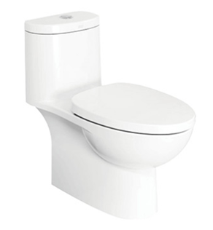

SPECIFICATIONS
- Litres Per Flush: 3/4.5 lpf
- P/S-Trap/Bowl Shape: S trap, elongated
- Roughing in: 305mm, 400mm floor discharge
- Overall Dimensions (LxBxH):
L709xW350xH712mm
- Height to Rim: 400mm
- Material: Vitreous China

DIMENSIONAL DRAWING
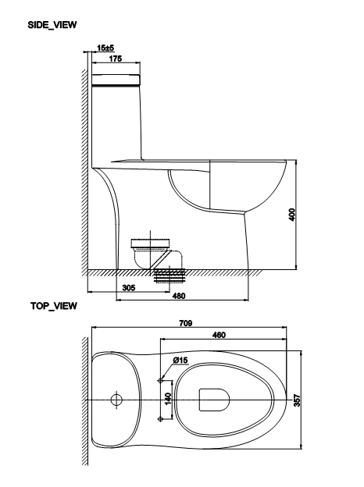
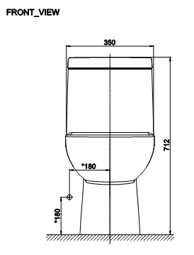
COLOR AVAILABILITY
- White only(0)
INCLUDED COMPONENTS
- PP Slow Closing Seat CCASC033-0200430C0
- Angle Valve and Water Supply Hose CC1-CN511MSA009182

STANDARDS CRITERIA
- China GB 6952-2005

This document is the property of American Standard. It can neither be reproduced, nor communicated, without authorization.
American Standard reserves the right to change dimensions and specifications without notice; we assume no liability for the use of obsolete dimensions.
STANDARDS CRITERIA
- TIS-792:2001
- GB 6952-2005
- PNS 156:2010
- MS 1522:2007
- SS 378-1996
- ASME-A112.19.2-2008

