Acacia E

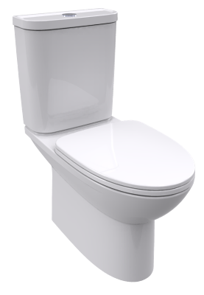vdalve & flexible hose CCAS2074-2200400C0
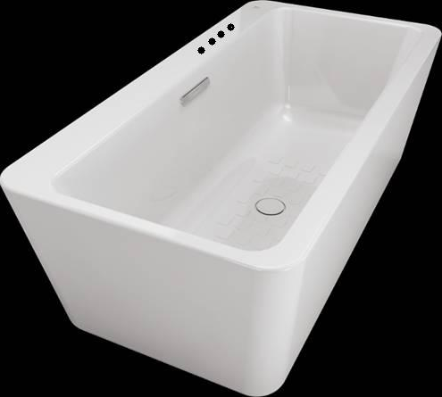
CT-6719.H56.04\Acacia E 1.7m Acrylic Seamless Floor-Standing Tub (w/ faucet installation holes)
BTAS6719-632AS00C5
FEATURES
- Use thick acrylic sheets, has better heat retaining property and more durable
- White super thin large flat water combine with the bath tub is fashion and generous
- Advanced seamless splicing technology makes skirt and cylinder splicing seamless, which show strong sense of design and easy to clean and maintain
- Wide cylinder design on one side as a practical storage area bring better practicability.

SPECIFICATIONS
- Installation Type: Free Standing
- Dimension: 1700x 850 x 580 mm
- Includes overflow hole
- Material: Acrylic

COLOR AVAILABILITY
- White only(0)

INCLUDED COMPONENTS
- Bath drain

SHIPPING WEIGHT
- Net Weight: 47 Kg
- Gross Weight: 56 Kg

STANDARD CRITERIA
- JC/T 779-2010

DIMENSIONAL DRAWING

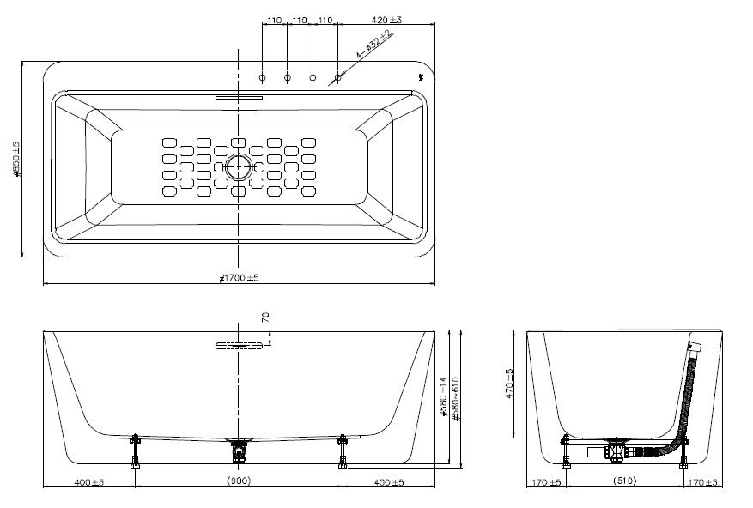

This document is the property of American Standard. It can neither be reproduced, nor communicated, without authorization.
American Standard reserves the right to change dimensions and specifications without notice; we assume no liability for the use of obsolete dimensions.

