Kastello

One Piece Toilet
CCAS2025/2026
FEATURES
- SiphonMax with Power Rim
- Water Saving
- ArmorLid with Slow Closing
- Aqua Ceramic, Comfort Clean Glaze

SPECIFICATIONS

Flushing Type: 3.8 Litres per flush
Flushing Activation: Side Lever
Roughing in : S-trap 305/400mm
Bowl shape: Elongate
Overall Dimensions: L743xW381xH695mm
Height to rim: 390 mm
Material: Vitreous China

SHIPPING WEIGHT
DIMENSIONAL DRAWING
Net Weight: 51 KG
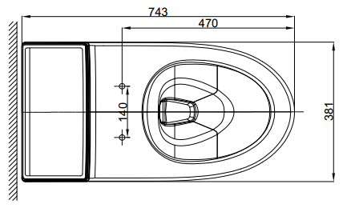
Gross Weight: TBD

INCLUDED COMPONENTS

Quick installation tape
Installation manual

STANDARDS CRITERIA
- GB6952-2015
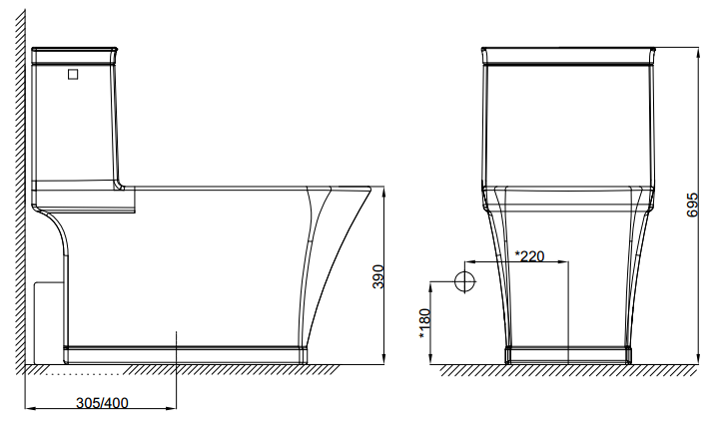
- KIS-2012

This document is the property of American Standard. It can neither be reproduced, nor communicated, without authorization.
American Standard reserves the right to change dimensions and specifications without notice; we assume no liability for the use of obsolete dimensions.

