

EasySET


Conceal Thermostatic Mixer with Trim
FFAS0930-709440BF0

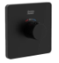

FEATURES

- Casting brass concealed body
- With Anti-scald protect button to avoid scalding
- With water temperature restrictor, the Max. temperature for the water
- cartridge tested = 30,000 times
- With normal packaging
- Flow rate @ 0.3MPa: 47 L/min

SPECIFICATIONS

Concealed control valve
By default the factory setting is 38 ℃ for the water coming out.
With water temperature restrictor,
the Max. temperature for the water coming out is lower than 49 ℃

DIMENSIONAL DRAWING

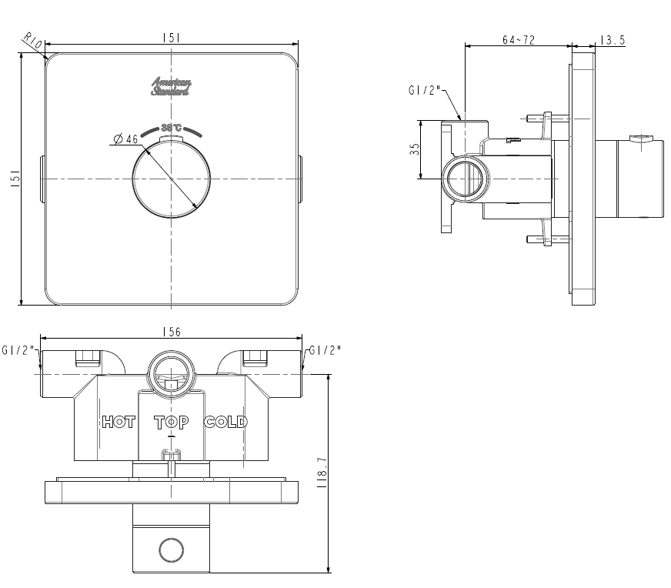
FINISHES AVAILABILITY

Matt Black Finish

AWARDS WON
N/A

SHIPPING WEIGHT
Product weight: 1.9 kg

STANDARDS CRITERIA
Q B 2806-2006
WI10.0589

This document is the property of American Standard. It can neither be reproduced, nor communicated, without authorization.
American Standard reserves the right to change dimensions and specifications without notice, we assume no liability for the use of obsolete dimensions.

