

Exposed EasySET

Auto Temperature Shower System（3-Way）
FFAS4956-601440BT0

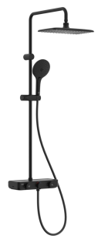

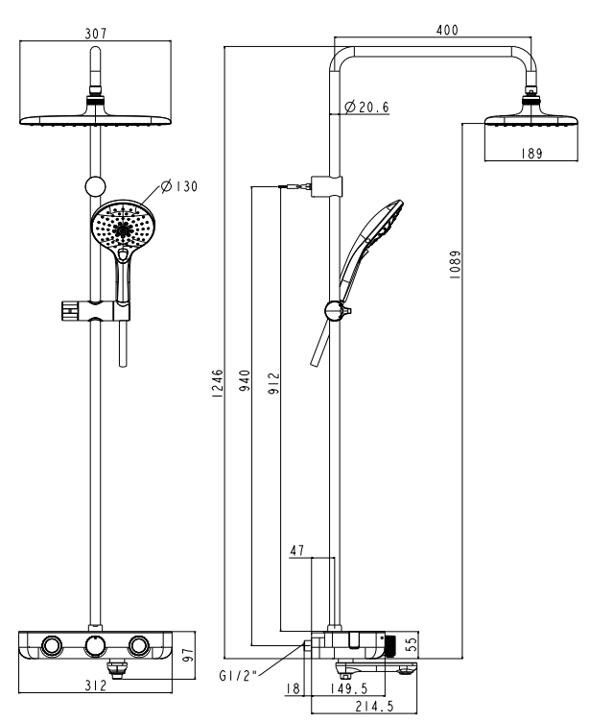
DIMENSIONAL DRAWING

FEATURES

- German thermostatic cartridge
- Anti-scald safestop button
- Push button cartridge with flow rate adjustable from Japan, life cycle ≥ 300,000 times
- Plastic body with cool touch design, no risk of scalding on the body
- Designed with a shelf space for storage function
- Side Hook on both side, as a shower accessories and drain the water on the top of Casting brass spout, rotate to divert the water to hand shower and spout
- 3-functions Rain Click hand shower, instinctive button for switching between spray modes
- PVC twist-free shower hose
- With easy glide shower holder
- With normal packaging
- 307*189 rectangle head shower, with air-in function
- Flow rate @ 0.1MPa: 4.3L/M for hand shower
- Flow rate @ 0.1MPa: 6 L/M for shower head
- Flow rate @ 0.1MPa: 12 L/M for Spout

SPECIFICATIONS

Exposed THM mixer faucet
Two-Hole Installation

FINISHES AVAILABILITY
Matt Black Finish
AWARDS WON
- N/A

SHIPPING WEIGHT
Product gross weight: 9.5 kg /set
Product net weight: 7.5 kg /set
STANDARDS CRITERIA
GB/T 2806-2017
WI10.0589

This document is the property of American Standard. It can neither be reproduced, nor communicated, without authorization.
American Standard reserves the right to change dimensions and specifications without notice, we assume no liability for the use of obsolete dimensions.
Rev.: D0

