

12" Head Shower for Exposed EasySET

FFASS515-000440BF0
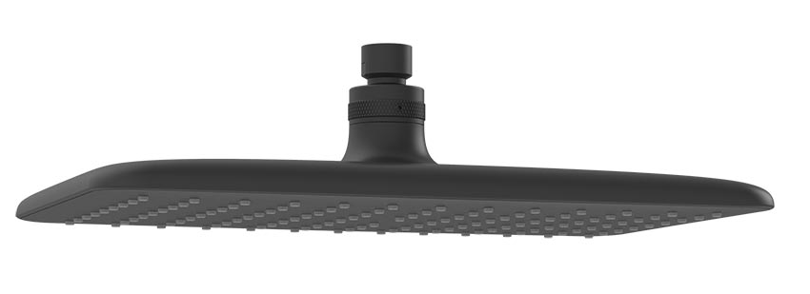

FEATURES

- ABS plastic body, Matt Black Cool Sunrise
- ABS plastic panel, black
- Gray TPR nipple
- With normal packaging
- Flow rate @ 0.1MPa: 6.9L/min

SPECIFICATIONS
1 function: Tranquil Rain
Panel dimension: 307mmX189mm

FINISHES AVAILABILITY

Matt Black Finish

AWARDS WON
- N/A

SHIPPING WEIGHT
Product gross weight: 11.28 kg/ set
Product net weight: 0.79 kg/ set
DIMENSIONAL DRAWING

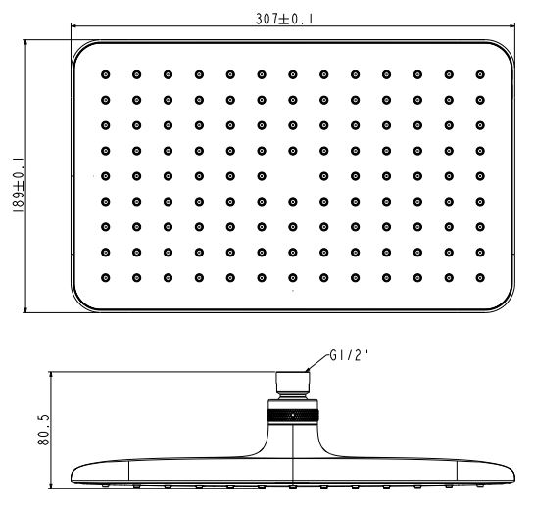
STANDARDS CRITERIA
GB 23447-2009
WI10.0589

This document is the property of American Standard. It can neither be reproduced, nor communicated, without authorization.
American Standard reserves the right to change dimensions and specifications without notice, we assume no liability for the use of obsolete dimensions.

