

i
Shower Hose
FFAS9127-000440BF0

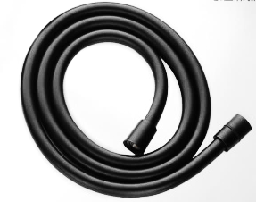

FEATURES

- Argent PVC hose,
- Twist-free function
- Brass Connector. Chromium plating.
- With normal packaging

SPECIFICATIONS

Both G1/2 female thread
Length: 1500 mm

FINISHES AVAILABILITY
DIMENSIONAL DRAWING

Matt Black Finish

AWARDS WON
- N/A

SHIPPING WEIGHT
Product gross weight: 0.34 kg/set
Product net weight: 0.27 kg/set
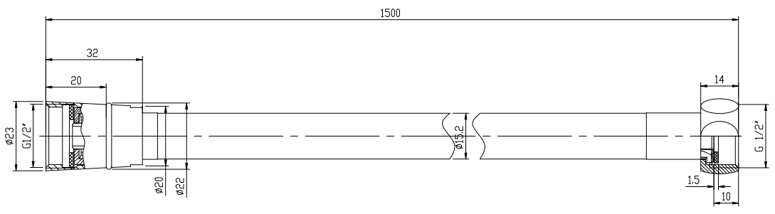
STANDARDS CRITERIA
GB/T 23448 -2009
WI10.0589

This document is the property of American Standard. It can neither be reproduced, nor communicated, without authorization.
American Standard reserves the right to change dimensions and specifications without notice, we assume no liability for the use of obsolete dimensions.

