

Rainclick

3 Function Hand Shower
FFAS9H11-000GL0BF0

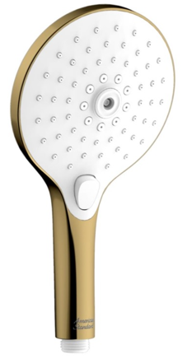

FEATURES

ABS plastic body, Cool Sunrise.
- ABS plastic panel, white.
- With normal packaging
- Flow rate @ 0.1MPa: 4.5 L/min

SPECIFICATIONS

3 function: Tranquil Rain, Jet Rain, Therapy Rain
Panel dimension: 130 mm

FINISHES AVAILABILITY
DIMENSIONAL DRAWING

Cool Sunrise Finish

AWARDS WON
- N/A

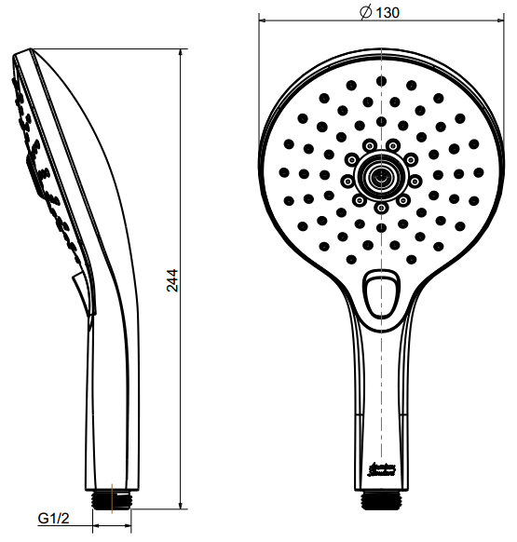
SHIPPING WEIGHT
Product gross weight: 0.37 kg/set
Product net weight: 0.28 kg/set

STANDARDS CRITERIA
GB/T 23447-2009
WI10.0575

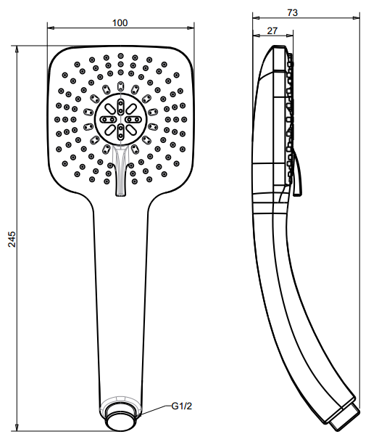

This document is the property of American Standard. It can neither be reproduced, nor communicated, without authorization.
American Standard reserves the right to change dimensions and specifications without notice, we assume no liability for the use of obsolete dimensions.

