

EasySET


Head Shower
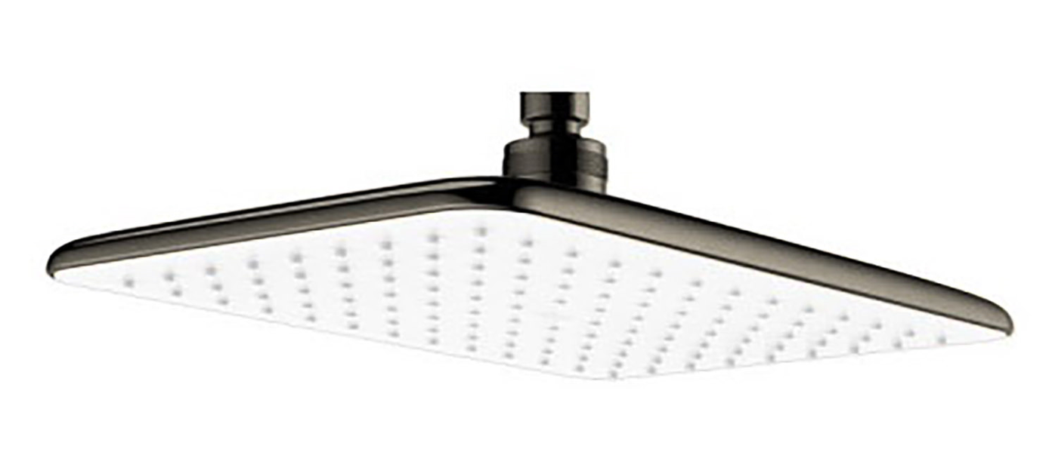
FFASS515-000AL0BF0

FEATURES

- PVD plated
- ABS Decoration
- With normal packaging
- Flow rate @ 0.1MPa: 7.21 L/min

SPECIFICATIONS

G1/2” for inlet

DIMENSIONAL DRAWING

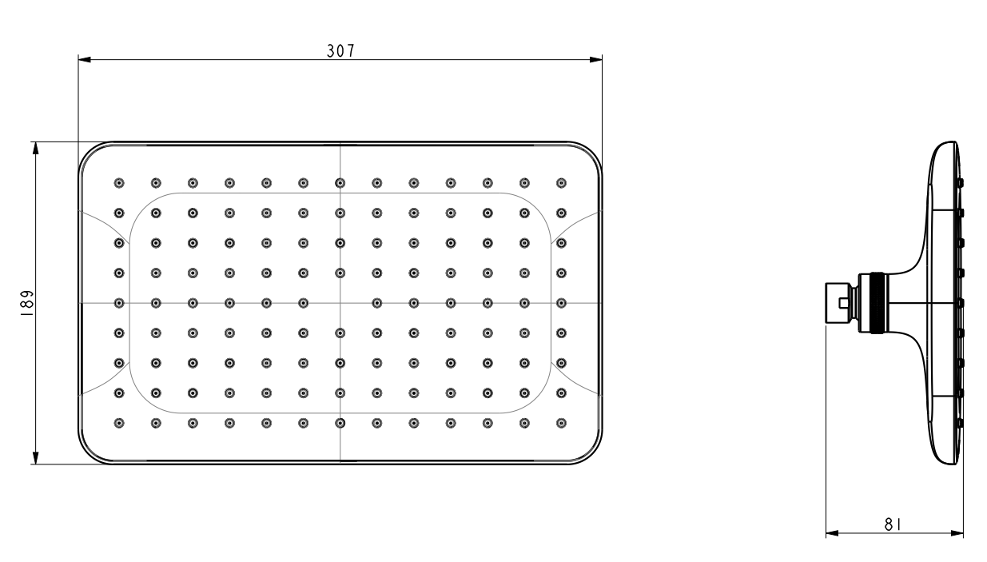
FINISHES AVAILABILITY

PVD Brushed Hard Graphite

AWARDS WON
N/A

SHIPPING WEIGHT
Product weight: 0.78 kg

STANDARDS CRITERIA
GB 18145-2014
WI10.0575

This document is the property of American Standard. It can neither be reproduced, nor communicated, without authorization.
American Standard reserves the right to change dimensions and specifications without notice, we assume no liability for the use of obsolete dimensions.

