Loven

FFAS1M06-101500BF0
Basin Mono Faucet

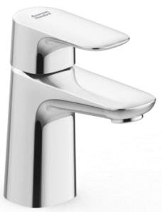

FEATURES

- Modern design that can fit with any style of bathroom
- Ceramic disc valve for a life time use
- Strong brass construction
- Nickel and chromium plating for durable finish
- W/O POP-UP Drain
- M24x1 1.5GPM PCA Aerator
- Flow Rate @ 0.1 MPa : 3.6 L/Min

SPECIFICATIONS
Basin mono faucet
Spout reach: 94 mm
Spout height: 83 mm
DIMENSIONAL DRAWING

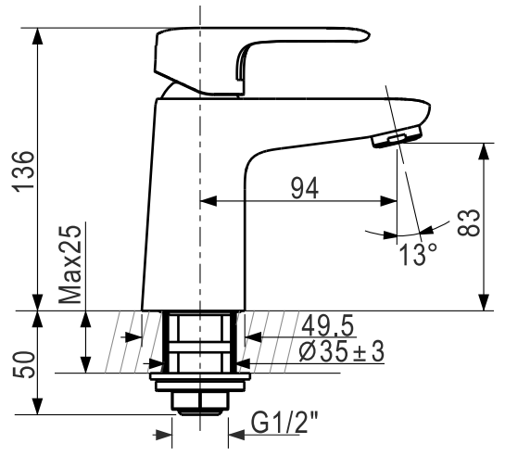
FINISHES AVAILABILITY

Chrome (- CP)

AWARDS WON
- N/A

SHIPPING WEIGHT
Product gross weight: 1.15kg /set
Product net weight: 1.0kg /set

STANDARDS CRITERIA
TIS 2067-2552
GB 18145-2014

This document is the property of American Standard. It can neither be reproduced, nor communicated, without authorization.
American Standard reserves the right to change dimensions and specifications without notice, we assume no liability for the use of obsolete dimensions.

