

In-wall Shower Arm

FFAS9909-000AL0BC0

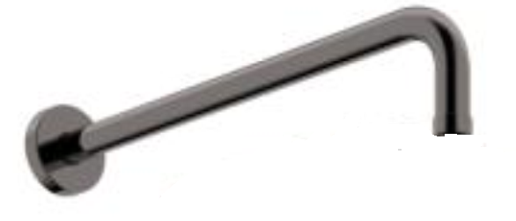

FEATURES

- A grade brass, strong and durable
- Brass escutcheon, chrome finish
- With normal packaging

SPECIFICATIONS

In-wall shower arm
Dimension: Φ24*300 mm

FINISHES AVAILABILITY

PVD Brushed Hard Graphite

AWARDS WON
- N/A

SHIPPING WEIGHT
Product gross weight: 0.6 kg/ set
Product net weight: 0.45 kg/ set
DIMENSIONAL DRAWING

STANDARDS CRITERIA
GB 23447-2009
WI10.0575

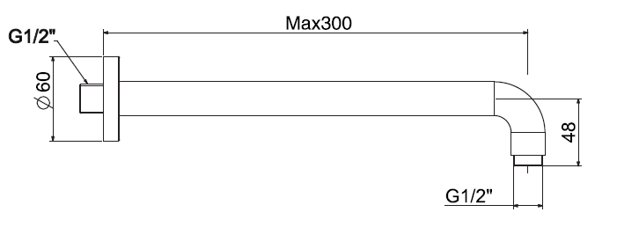

This document is the property of American Standard. It can neither be reproduced, nor communicated, without authorization.
American Standard reserves the right to change dimensions and specifications without notice, we assume no liability for the use of obsolete dimensions.

