

EasySET


Wall Outlet with holder – Square (G1/2”)
FFAS9143-000440BF0
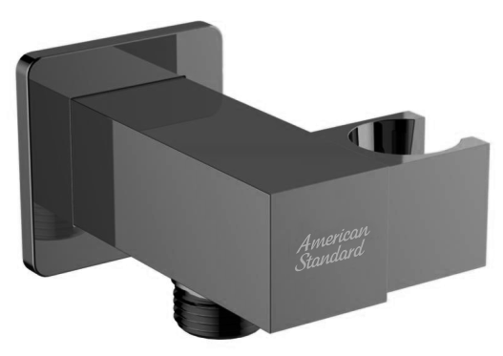

FEATURES

- Brass body, Matt Black plated
- Brass escutcheon, Matt Black plated
- With normal packaging
- Flow rate @ 0.1MPa: 49 L/min

SPECIFICATIONS

G1/2” for inlet and outlet

DIMENSIONAL DRAWING

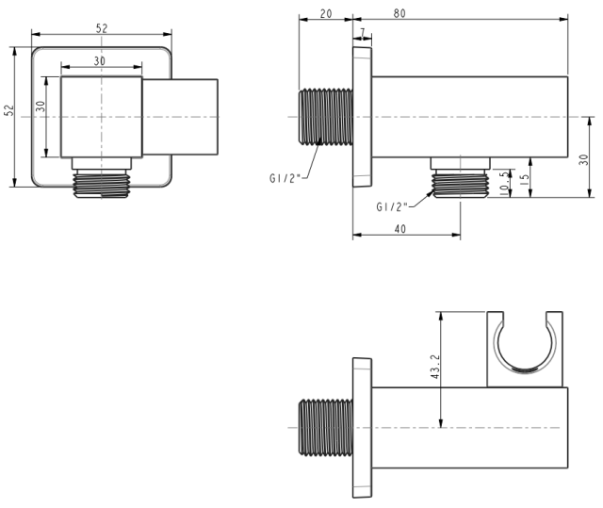
FINISHES AVAILABILITY

PVD Brushed Hard Graphite

AWARDS WON
N/A

SHIPPING WEIGHT
Product weight: 0.52 kg

STANDARDS CRITERIA
GB 18145-2014
WI10.0589

This document is the property of American Standard. It can neither be reproduced, nor communicated, without authorization.
American Standard reserves the right to change dimensions and specifications without notice, we assume no liability for the use of obsolete dimensions.

