

Shower


Concealed Body Shower
FFASS054-000AL0BC0
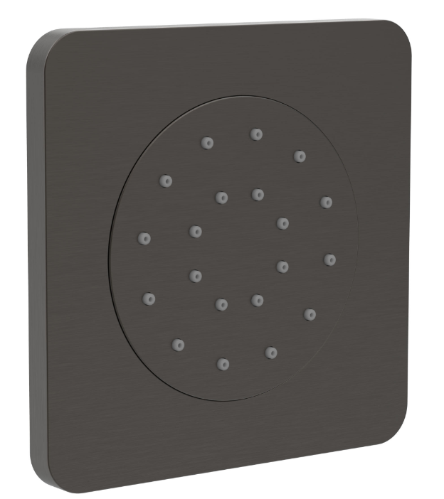

FEATURES

- Plastic escutcheon, chrome plated
- Single function
- With constant flow regulator for water saving.
- With normal packaging
- Flow rate @ 0.1MPa: ≤ 8 L/min

SPECIFICATIONS

Body shower with conceal body

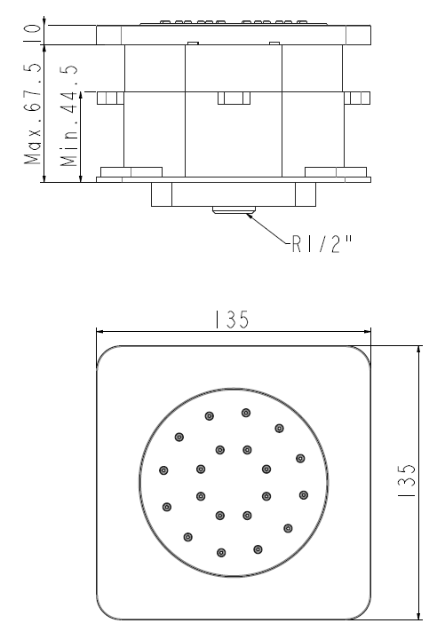
FINISHES AVAILABILITY
DIMENSIONAL DRAWING

PVD Brush Hard Graphite

AWARDS WON
N/A

SHIPPING WEIGHT
Product weight: 0.8 kg

STANDARDS CRITERIA
GB/T 23447-2009

This document is the property of American Standard. It can neither be reproduced, nor communicated, without authorization.
American Standard reserves the right to change dimensions and specifications without notice, we assume no liability for the use of obsolete dimensions.
Rev.: D/2

