

Kitchen Sink

Handmade one-bowl sink 800mm
101369MS00
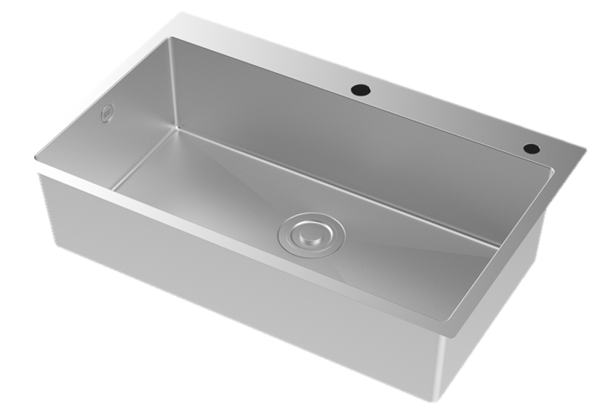

FEATURES

- High quality SUS304 stainless steel ,strong ability for anti-corrosion and anti-oxidation
- Handmade process and high-end satin finish
- Rearward- waste design
- Capacity (to overflow): 35L
- With SUS304 drain and PP Material Waste
- With box packaging

SPECIFICATIONS

Single bowl
Under counter
SUS304 sheet thickness 2.0mm(Panel)/1.0(Body)

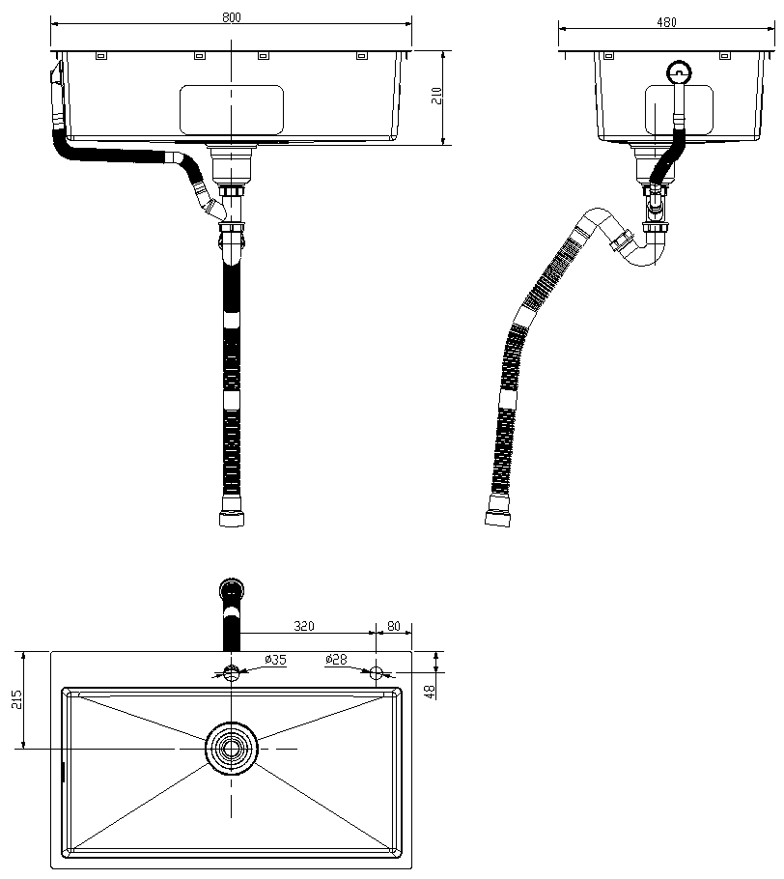
FINISHES AVAILABILITY
DIMENSIONAL DRAWING

Satin

AWARDS WON
- N/A

SHIPPING WEIGHT
Product weight: 10.9 kg

STANDARDS CRITERIA
Q/ASJM 004-2023

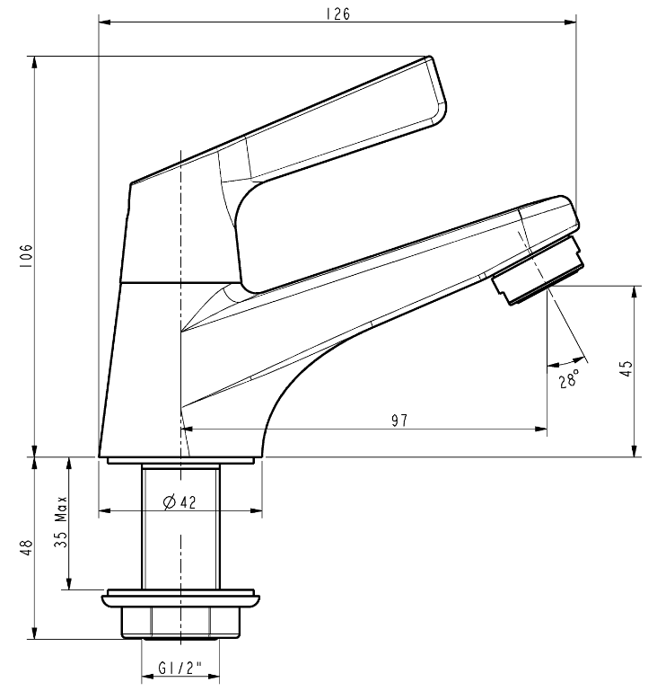

This document is the property of American Standard. It can neither be reproduced, nor communicated, without authorization.
American Standard reserves the right to change dimensions and specifications without notice, we assume no liability for the use of obsolete dimensions.

