

Kitchen Sink

Matt black synthetic two-bowl sink
1013672430

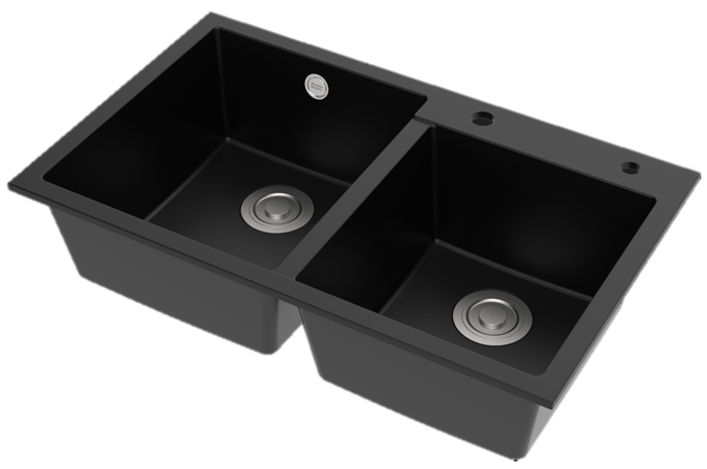

FEATURES

- Food grade synthetic material
- Matt Black finish and antibacterial
- Rearward- waste design
- Capacity (to overflow): 17.5/22L
- With SUS304 drain and PP Material Waste
- With box packaging

SPECIFICATIONS

Single bowl
Top/Under counter
synthetic thickness 8.5mm

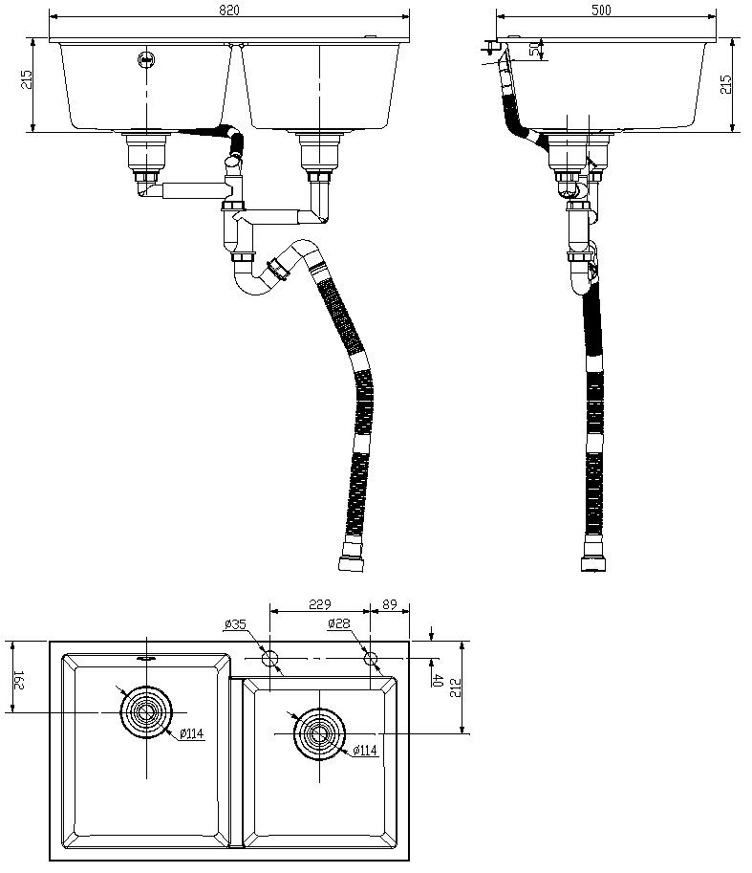
FINISHES AVAILABILITY
DIMENSIONAL DRAWING

Matt Black

AWARDS WON
- N/A

SHIPPING WEIGHT
Product weight: 16 kg

STANDARDS CRITERIA
GB 4806.7-2016

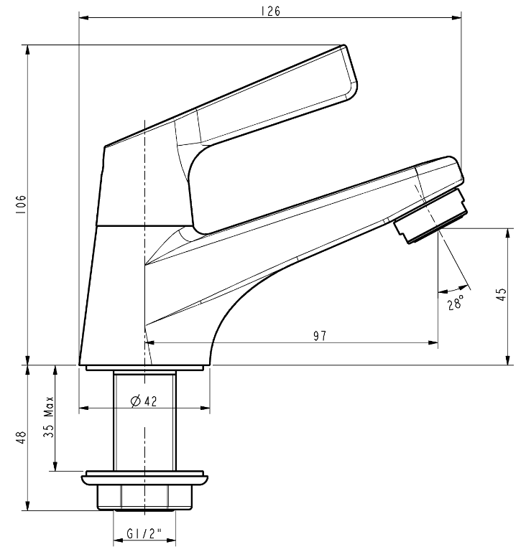

This document is the property of American Standard. It can neither be reproduced, nor communicated, without authorization.
American Standard reserves the right to change dimensions and specifications without notice, we assume no liability for the use of obsolete dimensions.

