

**Acacia Evolution**



Single-Hole Basin Mixer Faucet

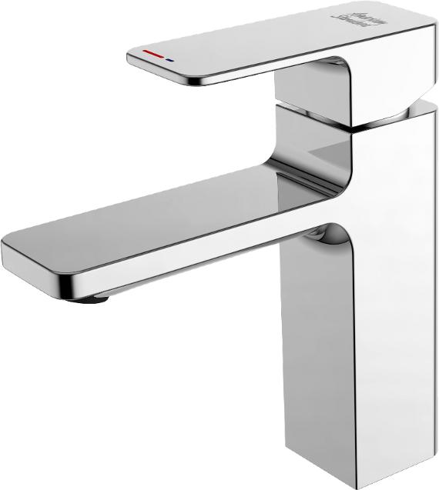

**FEATURES**

* Modern design that can fit with any style of bathroom
* **Eco-handle** for saving energy (electric power)
* **Click technology** offers 2 different water flow rates 0~50% and 50~100% for easy volume control and water saving
* Ceramic disc valve for a life time use
* Strong brass construction
* Nickel and chromium plating for durable finish
* Adjustable water stream direction aerator
* With Pop-up drain
* Flow Rate @ 0.1 MPa : 5.4 L/Min

**SPECIFICATIONS**

Single-Handle Basin Mixer Faucet

Single-Hole Installation

Spout Reach : 117 mm

Spout Height : 99mm

**DIMENSIONAL DRAWING**



**FINISHES AVAILABILITY**

Chrome (- CP)

**AWARDS WON**

* N/A

**SHIPPING WEIGHT**

Product weight: 1.52 kg

**STANDARDS CRITERIA**

TIS 2067-2552

GB 18145-2014

This document is the property of American Standard. It can neither be reproduced, nor communicated, without authorization.

American Standard reserves the right to change dimensions and specifications without notice, we assume no liability for the use of obsolete dimensions.