

Winston Tap

Deck Mounted Kitchen Faucet Mono (Cross Handle)
FFAST706-501500BF0

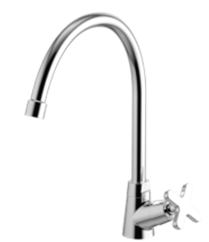

FEATURES

- A grade brass, strong and durable
- High quality ceramic valve for longer usage
- Ceramic cartridge tested =300,000 times
- Aerator 2.2 GPM
- Without pop-up drain
- With blister packaging
- Flow rate @ 0.1MPa: 4.6 L/min for spout

SPECIFICATIONS

Cross handle (cold)
Spout reach: 195 mm
Spout height: 196 mm

FINISHES AVAILABILITY
DIMENSIONAL DRAWING

Chrome (- CP)

AWARDS WON
- N/A

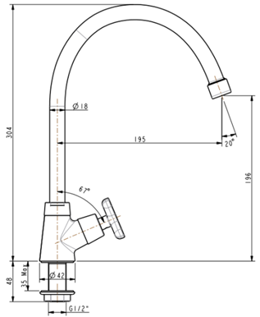
SHIPPING WEIGHT
Product gross weight: 0.72kg /set
Product net weight: 0.55kg /set

STANDARDS CRITERIA
TIS 2067-2552

This document is the property of American Standard. It can neither be reproduced, nor communicated, without authorization.
American Standard reserves the right to change dimensions and specifications without notice, we assume no liability for the use of obsolete dimensions.

