

Head Shower


FFASS052-006500BC0
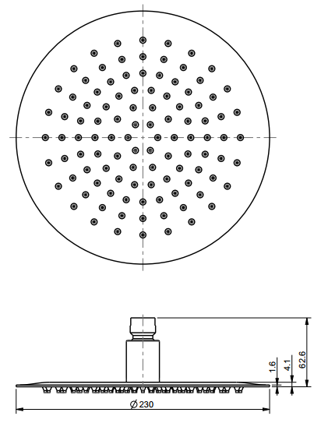
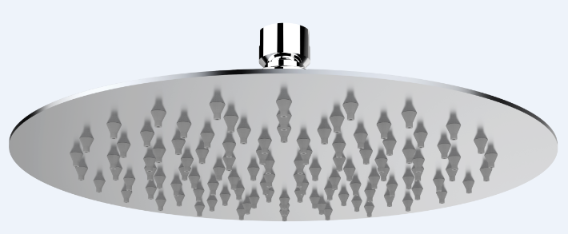
Super Thin 230mm Round Air-in Rain Shower Head

STANDARD SPECIFICATION

- SUS304 SS body, mirror polishing
- Brass connector, Chromium plating for durable finish
- Gray silicon nipple
- Flow rate @ 0.1 MPa (with regulator) 5.36 L/min

PRODUCT WEIGHT: 0.92 Kg

APPLICABLE CODES & STANDARDS:

- GB 23447-2009
STANDARDS CRITERIA

