

Head Shower


FFASS041-000500BC0
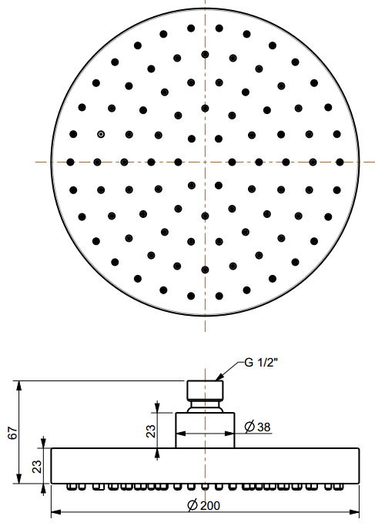
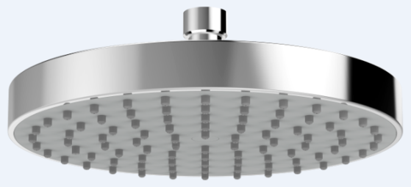
200mm Round Rain Shower Head

STANDARD SPECIFICATION

- ABS body
- ABS front panel, Gray
- ABS back cover, Chromium plating for durable finish
- Brass connector, Chromium plating for durable finish
- Gray TPR nipple
- Flow rate @ 0.1 MPa (with regulator) 4.68 L/min

PRODUCT WEIGHT: 0.66 Kg

APPLICABLE CODES & STANDARDS:

- GB 23447-2009
STANDARDS CRITERIA

