

Shower System


FFAS9081-100500BC0
Moonshadow Rainshower System HM204
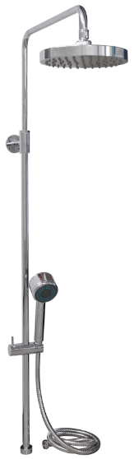

STANDARD SPECIFICATION

- Round Brass Tube, Chrome Finish
- W/ Adjustable Hanger
- W/ Stainless Steel Anti-twist Hose
- W/ Diverter
- W/ 3F Hand Shower, 3F: Spray, Massage, Spray+Massage
- W/ φ200mm Plastic Round Shower Head, Chrome Finish
- W/ Regulator, Flow Rate is less than 8L/min at 1bar

PRODUCT WEIGHT: 2.8 Kg

APPLICABLE CODES & STANDARDS:

- GB 23447-2009 + GB 18145
STANDARDS CRITERIA

