
Head Shower
FFASS034-006500BC0
Super Thin 300mm Square Rain Shower Head
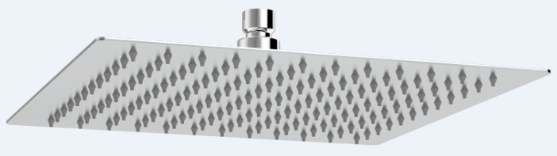

STANDARD SPECIFICATION

- SUS304 SS body, mirror polishing
- Brass connector, Chromium plating for durable finish
- Gray silicon nipple
- Flow rate @ 0.1 MPa (with regulator) 5.46 L/min

PRODUCT WEIGHT: 1.89 Kg

APPLICABLE CODES & STANDARDS:

- GB 23447-2009
STANDARDS CRITERIA

