

Head Shower


FFASS036-006500BC0
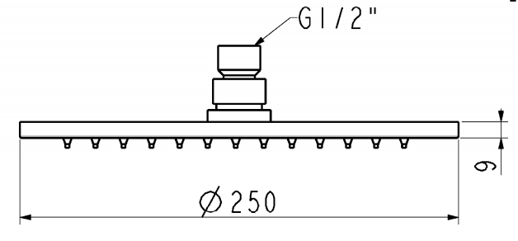
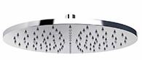
250mm R ou nd Air-in Brass Rain Shower Head

STANDARD SPECIFICATION

- Brass body
- Brass front panel, Chromium plating for durable finish
- Brass back cover, Chromium plating for durable finish
- Brass connector, Chromium plating for durable finish
- Silicon nipple
- Flow rate @ 0.1 MPa (with regulator) 5.37 L/min

PRODUCT WEIGHT: 1.32 Kg

APPLICABLE CODES & STANDARDS:

- GB 23447-2009
STANDARDS CRITERIA

