

Head Shower


FFASS049-000500BC0
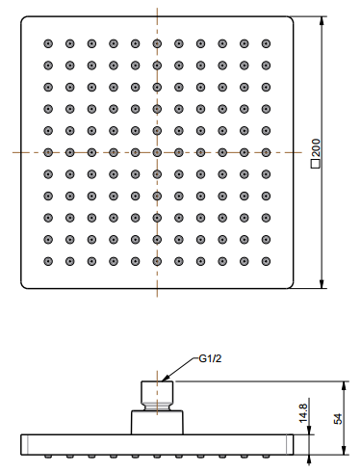
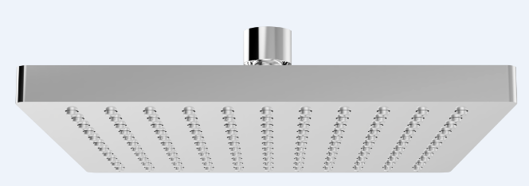
200mm Square Ra in Sho wer Head

STANDARD SPECIFICATION

- ABS body
- ABS front panel, Chromium plating for durable finish
- SUS304 SS back cover
- Brass connector, Chromium plating for durable finish
- Gray TPR nipple
- Flow rate @ 0.1 MPa (with regulator) 5.37 L/min

PRODUCT WEIGHT: 0.62 Kg

APPLICABLE CODES & STANDARDS:

- GB 23447-2009
STANDARDS CRITERIA

