Shower Head

FFASTS04-006500BF0
12" Round Brass Rain Shower Head with Air-in (w/o shower arm)

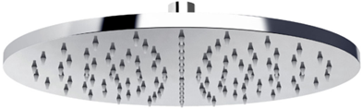

STANDARD SPECIFICATION

- Brass front body, chromium plating for durable finish
- Stainless steel back body, chromium plating for durable finish
- Brass connector, chromium plating for durable finish
- Gray silicon nozzle
- Air -In Technology
- W/o shower arm
- W/ DIY white box
- Flow rate @ 0.1 MPa (with regulator) 5.3 L/min

PRODUCT WEIGHT: 2.1 Kg

APPLICABLE CODES & STANDARDS:

- TIS 2066-2552
STANDARDS CRITERIA

