

Head Shower


FFASS040-006500BC0
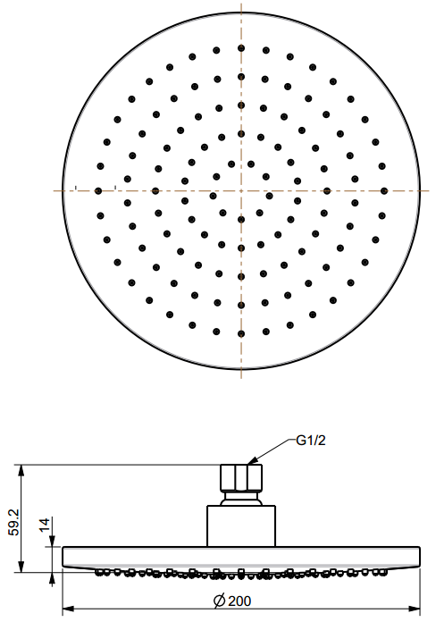
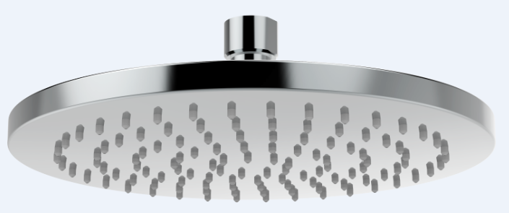
200mm Round Rain Shower Head with Air-in

STANDARD SPECIFICATION

- ABS body
- ABS front panel, Chromium plating for durable finish
- SUS304 SS back cover, mirror polishing
- Brass connector, Chromium plating for durable finish
- Gray TPR nipple
- Flow rate @ 0.1 MPa (with regulator) 6.12 L/min

PRODUCT WEIGHT: 0.61 Kg

APPLICABLE CODES & STANDARDS:

- GB 23447-2009
STANDARDS CRITERIA

