Shower Head

FFASTS02-006500BF0
12" Round Stainless Steel Rain Shower Head with Air-in (w/o shower arm)

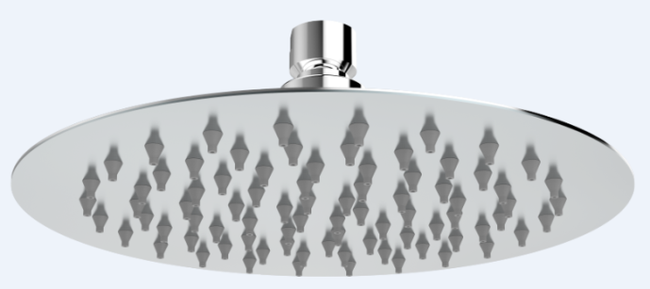

STANDARD SPECIFICATION

- SUS304 SS body, mirror polishing
- Brass connector, chromium plating for durable finish
- Gray silicone nozzle
- Air -In Technology
- W/o shower arm
- W/ DIY white box
- Flow rate @ 0.1 MPa (with regulator) 3.6 L/min

PRODUCT WEIGHT: 1.7 Kg

APPLICABLE CODES & STANDARDS:

- TIS 2066-2552
STANDARDS CRITERIA

