

Head Shower


FFASS045-006500BC0
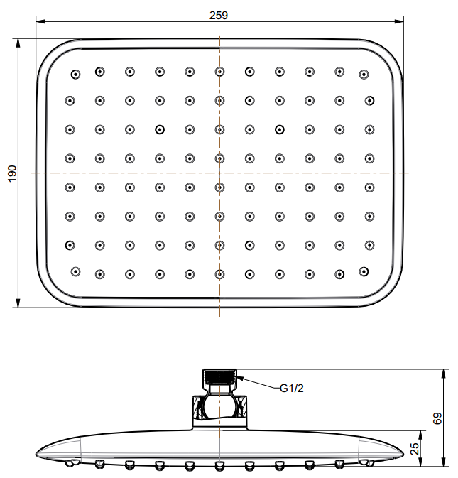
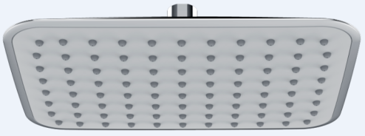
260x190m m Pl astic Rain Shower Head with Air-in

STANDARD SPECIFICATION

- ABS body
- ABS front panel, Gray
- ABS back cover, Chromium plating for durable finish
- Brass connector, Chromium plating for durable finish
- Gray TPR nipple
- Flow rate @ 0.1 MPa (with regulator) 5.29 L/min

PRODUCT WEIGHT: 0.67 Kg

APPLICABLE CODES & STANDARDS:

- GB 23447-2009
STANDARDS CRITERIA

