Milano

Exposed Bath & Shower Mixer
FFAS0911-629500BC0
FFAS0911-602501BF0
FFAS0911-6T2501BT0
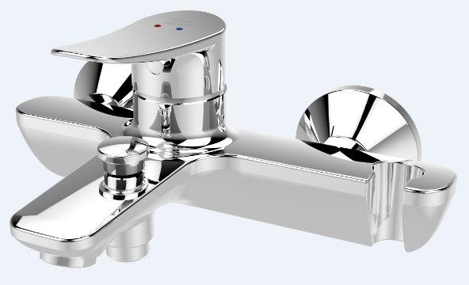

FEATURES

- A grade brass, strong and durable
- High quality ceramic valve for longer usage
- Ceramic cartridge tested = 500,000 times
- Neoperl aerator
- Without shower kits
- With normal packaging
- Flow rate @ 0.1MPa: 7.78 L/min for spout
- Flow rate @ 0.1MPa: 10.3 L/min for shower

SPECIFICATIONS

Exposed Bath & Shower Mixer Faucet
2-Hole Installation: lever handle (cold & hot)
Spout Reach: 127 mm

FINISHES AVAILABILITY

Chrome (- CP)

AWARDS WON
- N/A
DIMENSIONAL DRAWING

SHIPPING WEIGHT
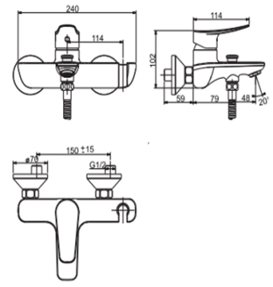
Product weight: 2.31 kg

STANDARDS CRITERIA
TIS 2066-2552
GB 18145-2014

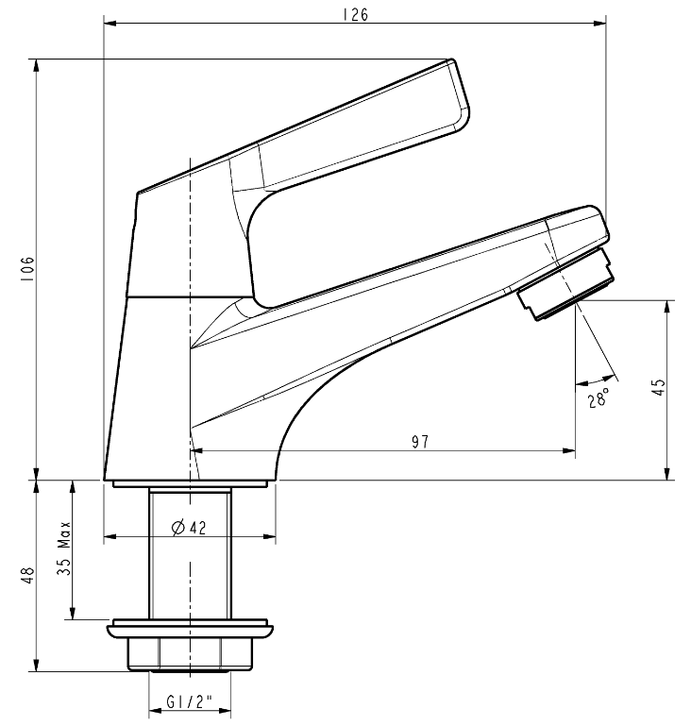

This document is the property of American Standard. It can neither be reproduced, nor communicated, without authorization.
American Standard reserves the right to change dimensions and specifications without notice, we assume no liability for the use of obsolete dimensions.

