

Head Shower


FFASS048-006500BC0
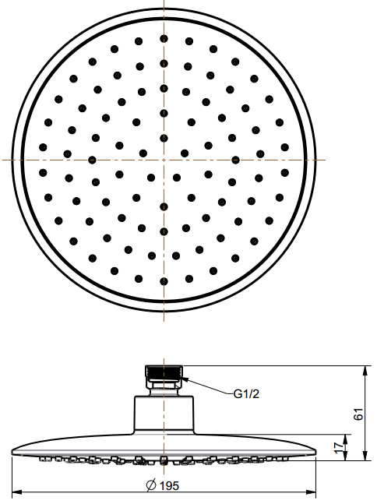
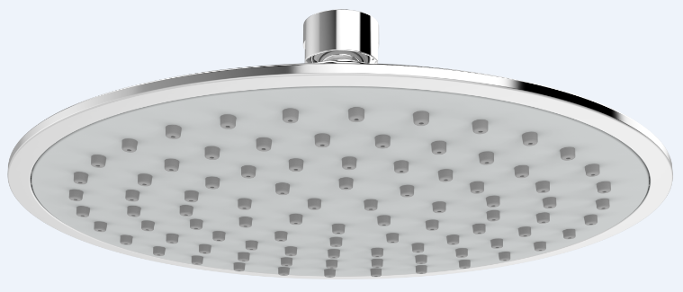
200mm UFO Air-in Rain Shower Head

STANDARD SPECIFICATION

- ABS body
- ABS front panel, Gray surface
- ABS back cover, Chromium plating for durable finish
- Brass connector, Chromium plating for durable finish
- Gray TPR nipple
- Flow rate @ 0.1 MPa (with regulator) 5.34 L/min

PRODUCT WEIGHT: 0.52 Kg

APPLICABLE CODES & STANDARDS:

- GB 23447-2009
STANDARDS CRITERIA

