

Head Shower


FFAS907C-100500BC0
Moonshadow Rainshower System HM204
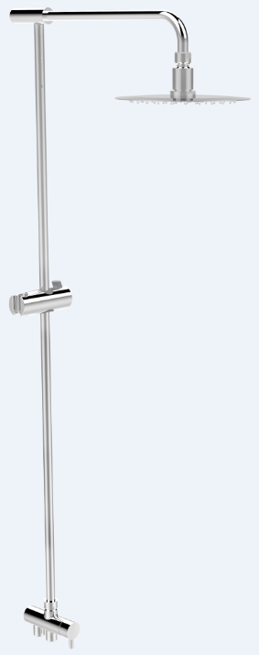

STANDARD SPECIFICATION

- Round Brass Tube, Chrome Finish
- Zinc Die Casting handle ,Chrome Finish
- Cast Brass Body ,Chrome Finish
- W/ Adjustable Hanger
- W/ Stainless Steel Hose
- W/ Diverter
- W/o Hand Shower
- W/ φ200mm Stainless Steel Air-in Round Shower Head, Mirror Polish
- Shower head Flow Rate at 3bar is 10.56L/min

PRODUCT WEIGHT: 2.8 Kg

APPLICABLE CODES & STANDARDS:

- GB 23447-2009 + GB 18145
STANDARDS CRITERIA

