Milano

Single Hole Vessel Faucet
FFAS0902-102501BF0

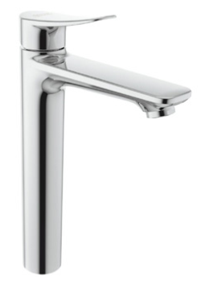

FEATURES

- A grade brass, strong and durable
- Germanic ceramic valve for longer usage
- Ceramic cartridge tested = 500,000 times
- Neoperl aerator
- Without pop-up drain
- With normal packaging
- Flow rate @ 0.42MPa: 5.5 L/min for spout

SPECIFICATIONS

Basin mixer faucet
1-hole installation: lever handle (cold & hot)
Spout reach: 153 mm
Spout height: 238mm

FINISHES AVAILABILITY
DIMENSIONAL DRAWING

Chrome (- CP)

AWARDS WON
- N/A

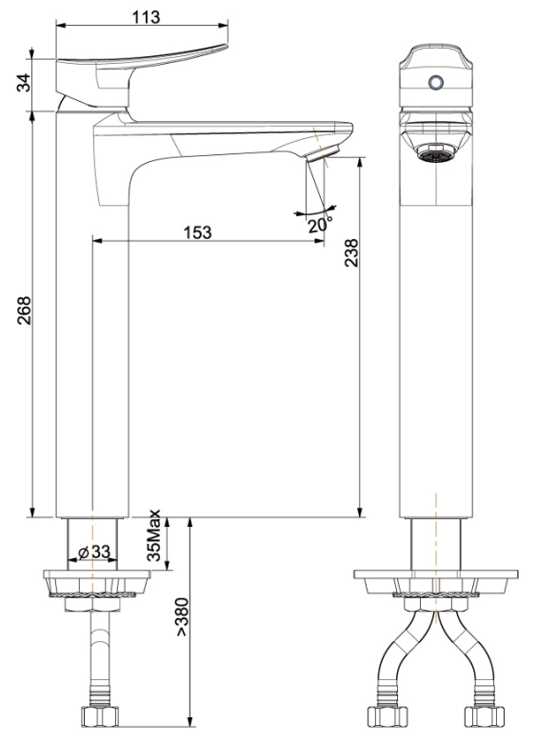
SHIPPING WEIGHT
Product gross weight:2.55kg/set
Product net weight: 2.05kg/set

STANDARDS CRITERIA
GB 18145-2014

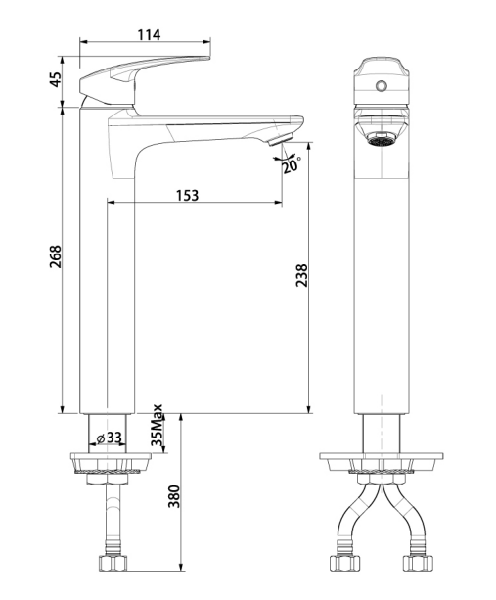

This document is the property of American Standard. It can neither be reproduced, nor communicated, without authorization.
American Standard reserves the right to change dimensions and specifications without notice, we assume no liability for the use of obsolete dimensions.

