

Concept Round

Concealed Only Shower Mixer
FFAS1422-709500BF0
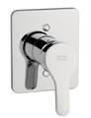

FEATURES

- A grade brass, strong and durable
- Ceramic cartridge lift time ≥500,000 times
- With normal packaging
- Flow rate @ 0.1MPa: 17.76 L/min (W/o Shower)

SPECIFICATIONS

Concealed Only Shower Mixer
Single handle control
● W/ Plastic Escutcheon
● W/o Shower Kits

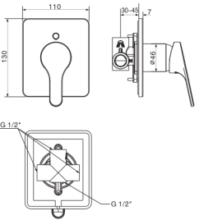
FINISHES AVAILABILITY
DIMENSIONAL DRAWING

Chrome (- CP)

AWARDS WON
N/A

SHIPPING WEIGHT
Product gross weight: 1.2 kg/set
Product net weight: 1.05 kg/set

STANDARDS CRITERIA
GB 18145-2014

This document is the property of American Standard. It can neither be reproduced, nor communicated, without authorization.
American Standard reserves the right to change dimensions and specifications without notice, we assume no liability for the use of obsolete dimensions.

