
Acacia SupaSleek

Extended Basin Mixer
1124150000

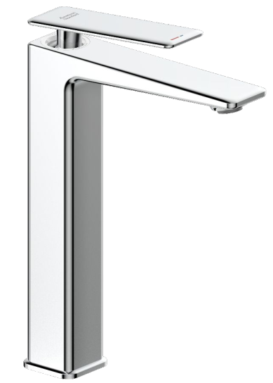

FEATURES

- Modern design that can fit with any style of bathroom
- Cold-Start handle for saving energy
- Lixil 28 Cartridge for a life time use
- Strong brass construction
- Nickel and chromium plating for durable finish
- M24x1 1.2GPM Ecojoy 2 Aerator
- With Pop-up drain
- Flow Rate @ 0.1 MPa : 3.83 L/Min

SPECIFICATIONS

Basin mixer faucet
1-Hole Installation: lever handle (cold & hot)
Spout reach: 156 mm
DIMENSIONAL DRAWING

Spout height: 231 mm
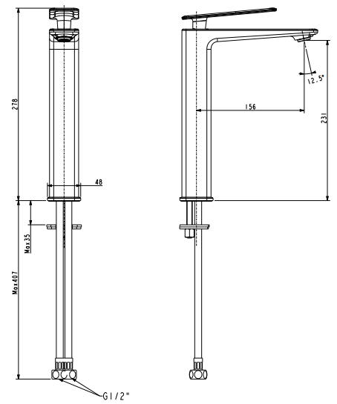

FINISHES AVAILABILITY

Chrome (- CP)

AWARDS WON
- N/A

SHIPPING WEIGHT
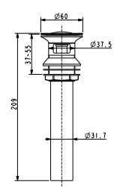
Product gross weight: 2.68 kg/set
Product net weight: 2.3 kg/set

STANDARDS CRITERIA
GB 18145-2014

This document is the property of American Standard. It can neither be reproduced, nor communicated, without authorization.
American Standard reserves the right to change dimensions and specifications without notice, we assume no liability for the use of obsolete dimensions.

