
Acacia SupaSleek

Wall Mount Basin Mixer
1124170000

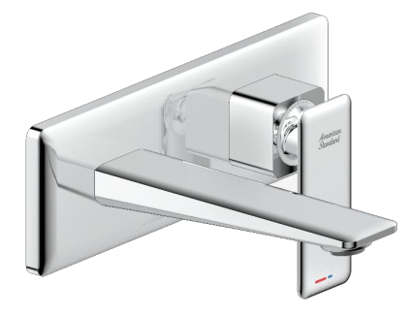

FEATURES

- Modern design that can fit with any style of bathroom
- Cold-Start handle for saving energy
- Lixil 28 Cartridge for a life time use
- Strong brass construction
- Nickel and chromium plating for durable finish
- M24x1 1.2GPM Ecojoy 2 Aerator
- With Pop-up drain
- Flow rate @ 0.1MPa: 4.0 L/min

SPECIFICATIONS
DIMENSIONAL DRAWING

Concealed vessel faucet
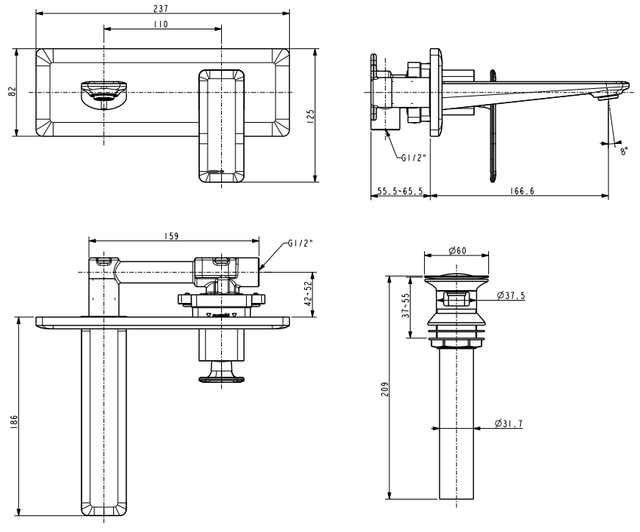
2-Hole Installation: lever handle (cold & hot)
Spout reach: 167~177 mm
Escutcheon size: 237x82 mm

FINISHES AVAILABILITY

Chrome (- CP)

AWARDS WON
- N/A

SHIPPING WEIGHT
Product gross weight: 2.76 kg/set
Product net weight: 2.5 kg/set

STANDARDS CRITERIA
GB 18145-2014

This document is the property of American Standard. It can neither be reproduced, nor communicated, without authorization.
American Standard reserves the right to change dimensions and specifications without notice, we assume no liability for the use of obsolete dimensions.

