
Soap dispenser



Soap dispenser (White）1072689990
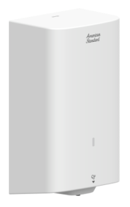

FEATURES

- ABS shell
- Infrared Sensor
- Sensor distance:5-9CM
- DC 6V(4pcs AA Alkaline battery)
- Soap capacity:1000CC
- Low battery voltage warning
- IPX4

SPECIFICATIONS

Sensor Soap dispenser
Dimension:240x138x94

FINISHES AVAILABILITY

White

AWARDS WON
- N/A
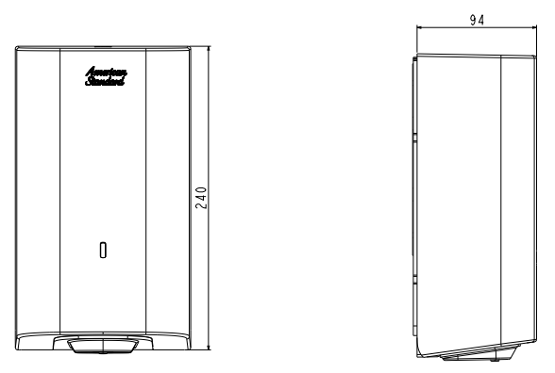
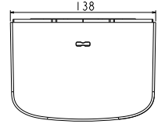
DIMENSIONAL DRAWING

SHIPPING WEIGHT
Product net weight: 0.7 kg/set
Product gross weight: 0.83kg /set

STANDARDS CRITERIA
N/A

This document is the property of American Standard. It can neither be reproduced, nor communicated, without authorization.
American Standard reserves the right to change dimensions and specifications without notice, we assume no liability for the use of obsolete dimensions.

