
Acacia SupaSleek

Bath Spout Without Diverter
1136630000

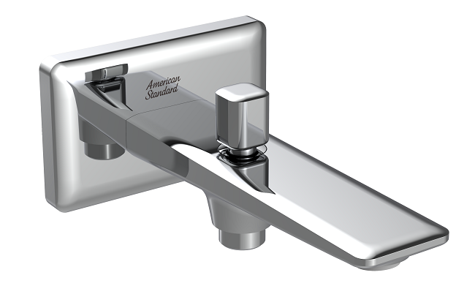

FEATURES

A grade brass,strong and durable
- Brass escutcheon, Chrome finish
- SupaSleek Bath Spout
- Neoperl aerator
- With Diverter
- With normal packaging
- Flow rate (spout outlet) @ 0.1MPa: 21.9 L/min
- Flow rate (shower outlet) @ 0.1MPa: 15.8 L/min

SPECIFICATIONS

In-wall bath spout
Dimension:188.5*117*75.9

DIMENSIONAL DRAWING

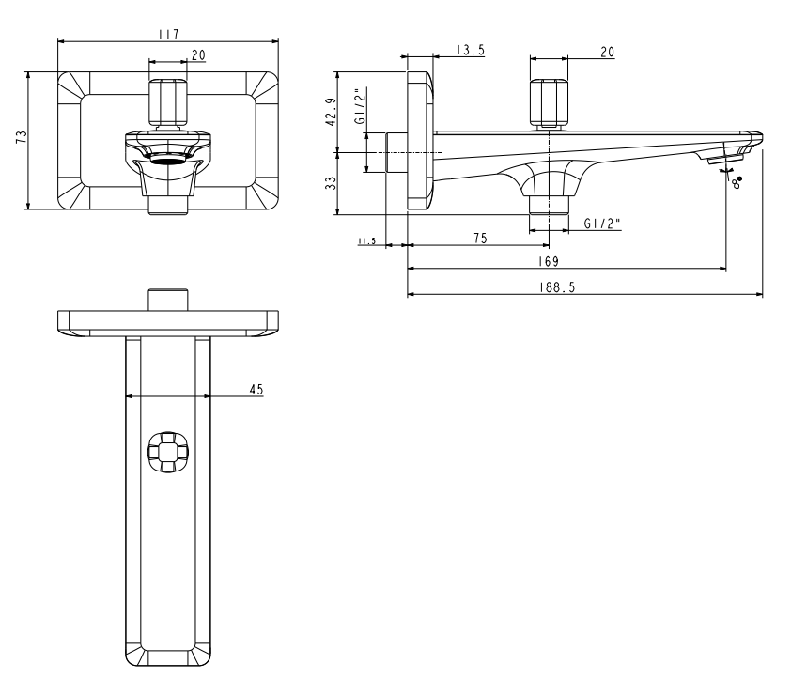
FINISHES AVAILABILITY

Chrome Finish

AWARDS WON
- N/A

SHIPPING WEIGHT
Product gross weight: 0.996 kg/set
Product net weight: 0.946kg/set

STANDARDS CRITERIA
GB 18145-2014

This document is the property of American Standard. It can neither be reproduced, nor communicated, without authorization.
American Standard reserves the right to change dimensions and specifications without notice, we assume no liability for the use of obsolete dimensions.

