
Accessory

SHOWER ARM FOR RAIN SHOWER 17” MED
F41026-CHACT

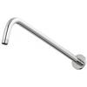

FEATURES

- A grade brass, strong and durable
- Brass escutcheon, chrome finish
- With normal packaging

SPECIFICATIONS

Ceiling shower arm
Dimension: Φ21*434.5 mm

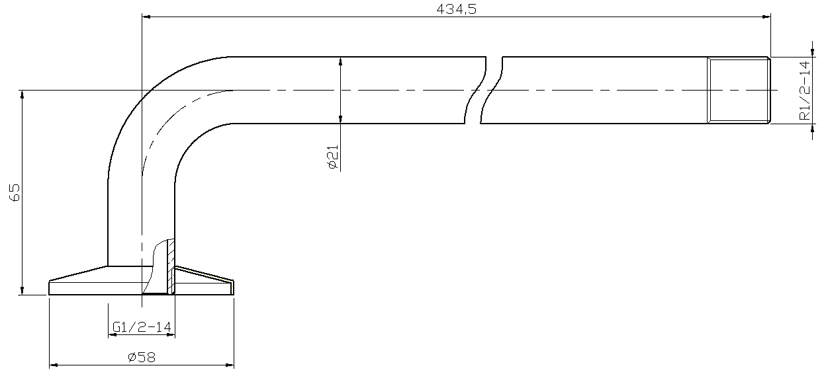
FINISHES AVAILABILITY
DIMENSIONAL DRAWING

Chrome (- CP)

AWARDS WON
- N/A

SHIPPING WEIGHT
Product weight (NW): 0.6kg

STANDARDS CRITERIA
N/A

This document is the property of American Standard. It can neither be reproduced, nor communicated, without authorization.
American Standard reserves the right to change dimensions and specifications without notice, we assume no liability for the use of obsolete dimensions.

