
WizFlo

WizFlo Flex Hand Shower -APAC
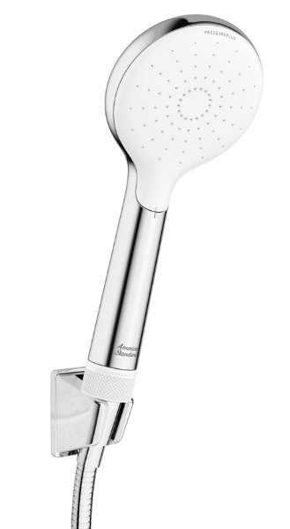
1361450000

FEATURES

- ABS plastic body, Chrome body.
- ABS+PC spray face, white.
- With color box packaging
- Easy open to clean for the spray face
- With water pressure adjustable
- With Shower holder
- With 1.5M Twist-free shower hose
- Flow rate @ 0.1Mpa : 6.9 L/min

SPECIFICATIONS
- Spray face dimension: 100 mm

DIMENSIONAL DRAWING
FINISHES AVAILABILITY
Chrome (- CP)

AWARDS WON
- Red Dot
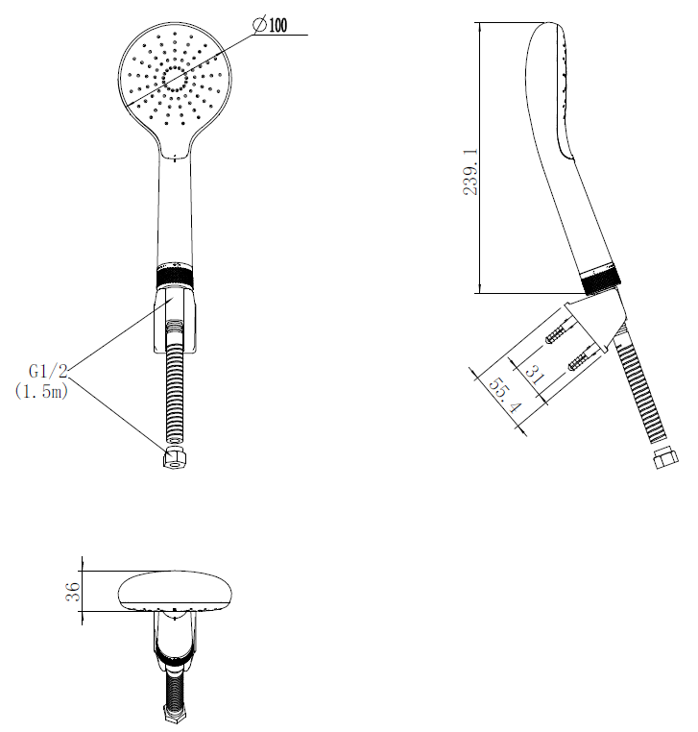
SHIPPING WEIGHT
Product gross weight: 0.51 kg/set
Product net weight: 0.41 kg/set

STANDARDS CRITERIA
GB/T 23447-2023

This document is the property of American Standard. It can neither be reproduced, nor communicated, without authorization.
American Standard reserves the right to change dimensions and specifications without notice, we assume no liability for the use of obsolete dimensions.

