

Acacia-E

Concealed Bath & Shower Mixing Valve
FFAS1321-608DA0BF0
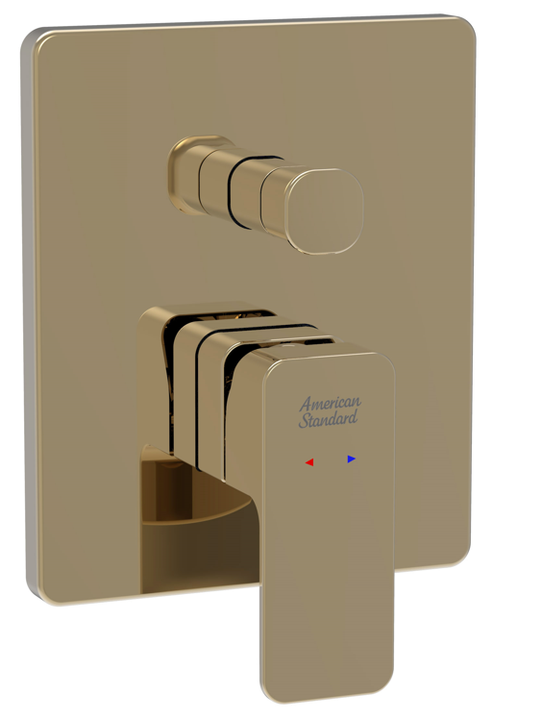

FEATURES

- A grade brass, strong and durable
- High quality ceramic valve for longer usage
- Ceramic cartridge tested = 500,000 times
- Brass escutcheon, PVD Warm Sunset
- Without spout & shower kits
- With normal packaging
- Flow rate @ 0.1MPa: 13.3 L/min for spout outlet
- Flow rate @ 0.1MPa: 13.8 L/min for shower outlet

SPECIFICATIONS

Concealed bath & shower mixing valve
1-hole installation: lever handle (cold & hot)
Escutcheon size: 150*180mm

FINISHES AVAILABILITY
DIMENSIONAL DRAWING

PVD Warm Sunset

AWARDS WON
- N/A

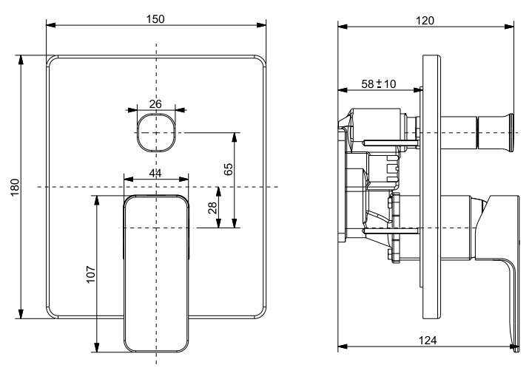
SHIPPING WEIGHT
Product gross weight: 2.5kg /set
Product net weight: 2.3kg /set

STANDARDS CRITERIA
GB 18145-2014
WI10.0575

This document is the property of American Standard. It can neither be reproduced, nor communicated, without authorization.
American Standard reserves the right to change dimensions and specifications without notice, we assume no liability for the use of obsolete dimensions.

