

Acacia-E


Concealed Shower Main Mixing Valve
FFAS1322-708DA0BF0
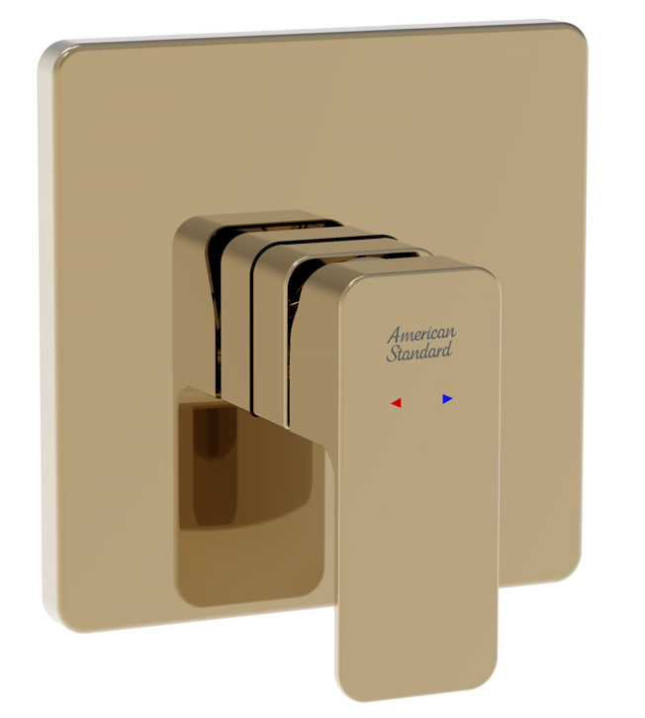

FEATURES

- DZR brass body, strong and durable
- High quality ceramic valve for longer usage
- Ceramic cartridge tested = 500,000 times
- Brass escutcheon,
- PVD (- Warm Sunset)
- Without shower kits
- Without u-box
- With normal packaging
- Flow rate @ 0.1MPa: 16.6 L/min for shower outlet

SPECIFICATIONS

Concealed Shower Mixing Valve
WaterMark certification

FINISHES AVAILABILITY

PVD (- Warm Sunset)
AWARDS WON
- N/A

DIMENSIONAL DRAWING

SHIPPING WEIGHT
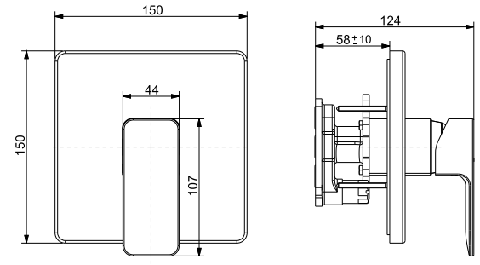
Product gross weight: 1.9 kg /set
Product net weight: 1.7 kg /set

STANDARDS CRITERIA
AS/NZS 3718:2005
AS/NZS 6400:2016

This document is the property of American Standard. It can neither be reproduced, nor communicated, without authorization.
American Standard reserves the right to change dimensions and specifications without notice, we assume no liability for the use of obsolete dimensions.

