

Concept Square

Concept Square Single Tissue Holder w/ Shelf
FFAS0498-908DA0BF0

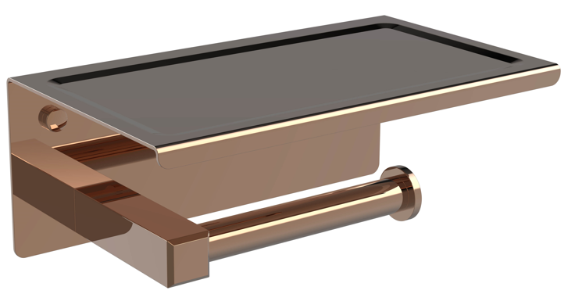

FEATURES

- Modern design
- SUS304 stainless steel shelf, PVD finish
- Zinc die casting support pole
- SUS201 cross bar & screw
- Black color box packaging

SPECIFICATIONS

Tissue holder with shelf

DIMENSIONAL DRAWING

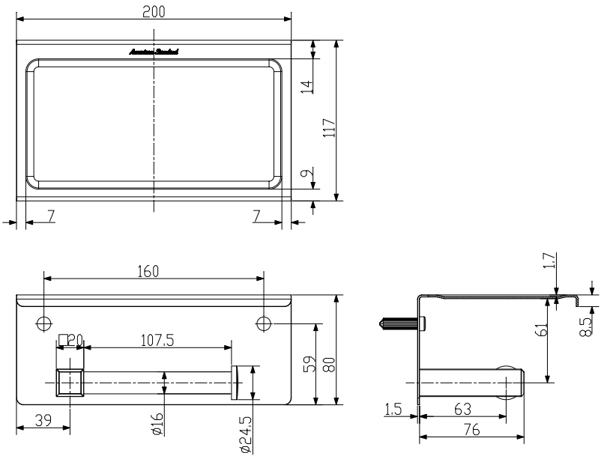
FINISHES AVAILABILITY

PVD Warm Sunset

AWARDS WON
N/A

SHIPPING WEIGHT
Product gross weight: 0.8kg/ set
Product net weight: 0.62kg/ set

STANDARDS CRITERIA
QB/T 1560-2017

This document is the property of American Standard. It can neither be reproduced, nor communicated, without authorization.
American Standard reserves the right to change dimensions and specifications without notice, we assume no liability for the use of obsolete dimensions.
Rev.: D/0

