
Simplica
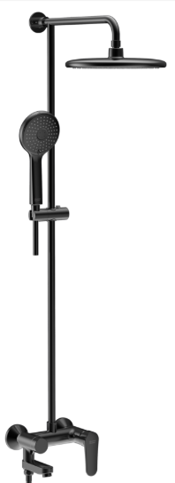

Simplica 3-way RS Kit（P/D）_MB_APAC
1362842430
FEATURES
- A grade brass, strong and durable
- High quality ceramic valve for longer usage
- 3 way Ceramic diverter for longer usage
- Brass rotatable spout with Neoperl exposed aerator
- With 3 functions hand shower
- With φ254mm head shower
- With 1.5M Twist-free PVC shower hose
- With height adjustable shower Hanger
- With normal packaging
- Flow rate：@ 0.1MPa，8.4 L/min for Spout
- Flow rate：@ 0.1MPa，4.8 L/min for hand shower
- Flow rate：@ 0.1MPa，5.7 L/min for shower head

SPECIFICATIONS
- Exposed bath & shower mixer
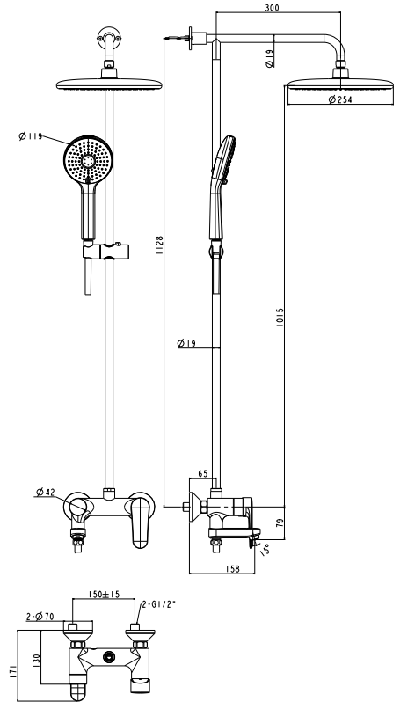
- Double handle and double control（Adjustable flow and outlet water temperature）

Dimensional Drawing
- φ254mm Plastic Round Shower Head

FINISHES AVAILABILITY
- Matte Black
AWARDS WON
- N/A
SHIPPING WEIGHT
- Product gross weight: 6.6 kg/set
- Product net weight: 6.4 kg/set
STANDARDS CRITERIA
- GB 18145-2014

This document is the property of American Standard. It can neither be reproduced, nor communicated, without authorization.
American Standard reserves the right to change dimensions and specifications without notice, we assume no liability for the use of obsolete dimensions.

