

EasySET


EasySET for Head Shower
FFAS0926-709500BC0

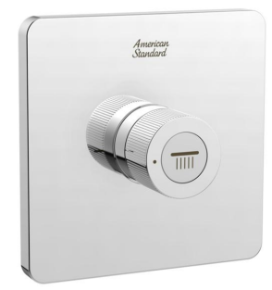

FEATURES

- Casting brass concealed body
- On/Off by the push function
- cartridge tested = 200,000 times
- With normal packaging
Flow rate @ 0.3MPa: 46 L/min

SPECIFICATIONS

Concealed control valve
Volume adjustment by the knob

FINISHES AVAILABILITY

Chrome (- CP)

AWARDS WON
- N/A

SHIPPING WEIGHT
Product weight: 1.3 kg
DIMENSIONAL DRAWING

STANDARDS CRITERIA
QBT 1334-2013

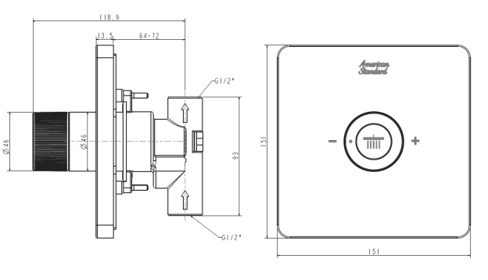

This document is the property of American Standard. It can neither be reproduced, nor communicated, without authorization.
American Standard reserves the right to change dimensions and specifications without notice, we assume no liability for the use of obsolete dimensions.

