

Ceiling Shower Arm

FFAS9908-000GL0BF0

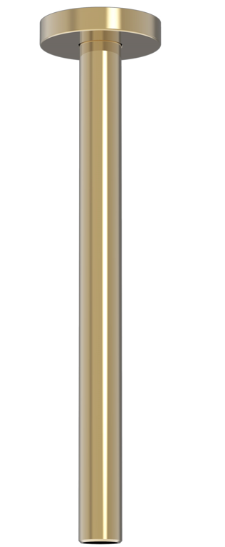

FEATURES

- A grade brass, strong and durable
- Brass escutcheon,
- PVD (-Cool Sunrise)
- With normal packaging

SPECIFICATIONS

Ceiling type
Dimension: Φ20.6*252 mm

FINISHES AVAILABILITY
DIMENSIONAL DRAWING

PVD (-Cool Sunrise)

AWARDS WON
- N/A

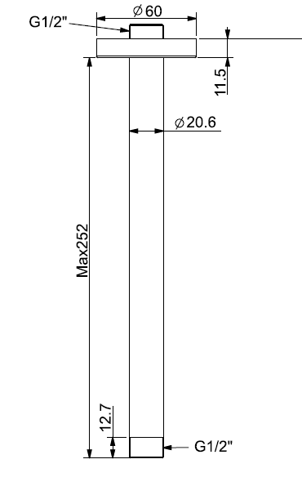
SHIPPING WEIGHT
Product gross weight: 0.4 kg /set
Product net weight: 0.25 kg /set

STANDARDS CRITERIA
GB 23447-2009

This document is the property of American Standard. It can neither be reproduced, nor communicated, without authorization.
American Standard reserves the right to change dimensions and specifications without notice, we assume no liability for the use of obsolete dimensions.

