

Kitchen Sink

under counter design one-bowl sink 673mm
101373MS00
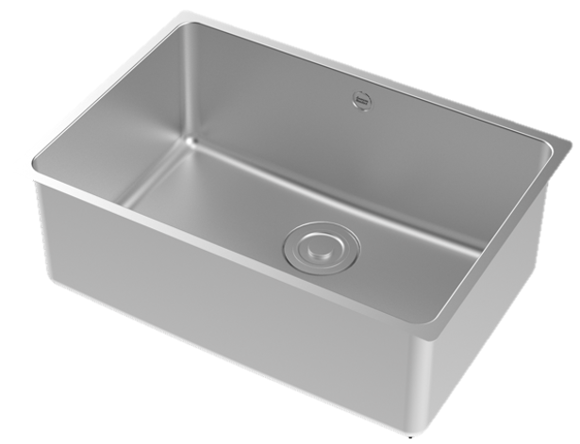

FEATURES

- High quality SUS304 stainless steel ,strong ability for anti-corrosion and anti-oxidation
- High-end satin finish
- Deep flap design
- Rearward- waste design
- Capacity (to overflow): 38L
- With SUS304 drain and PP Material Waste
- With box packaging

SPECIFICATIONS

Single bowl
Under counter
SUS304 sheet thickness 1.2mm

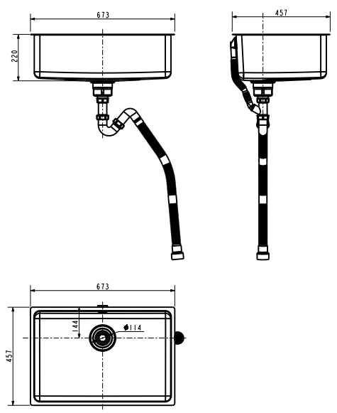
FINISHES AVAILABILITY
DIMENSIONAL DRAWING

Satin

AWARDS WON
- N/A

SHIPPING WEIGHT
Product weight: 5.6 kg

STANDARDS CRITERIA
Q/ASJM 004-2023

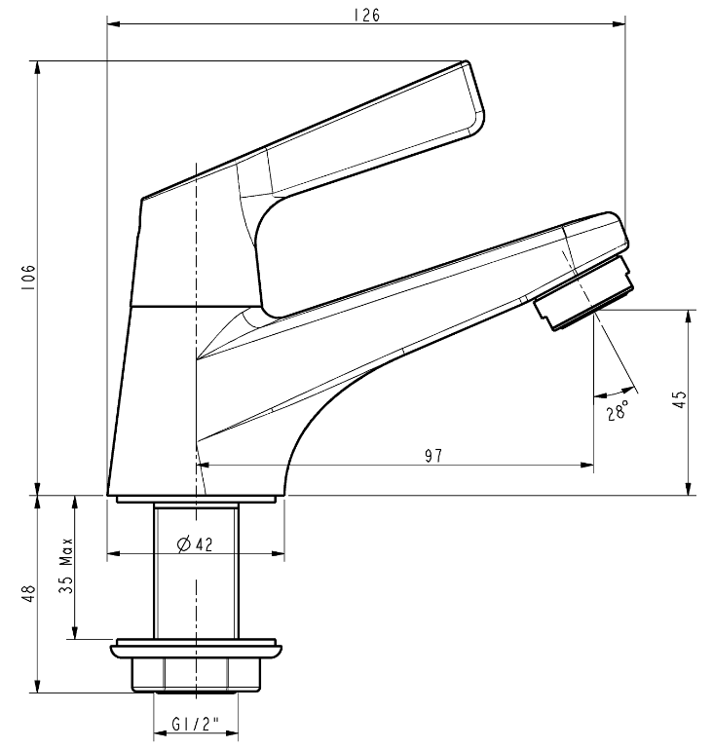

This document is the property of American Standard. It can neither be reproduced, nor communicated, without authorization.
American Standard reserves the right to change dimensions and specifications without notice, we assume no liability for the use of obsolete dimensions.

