

Shower


Concealed Body Shower
FFASS054-000440BF0
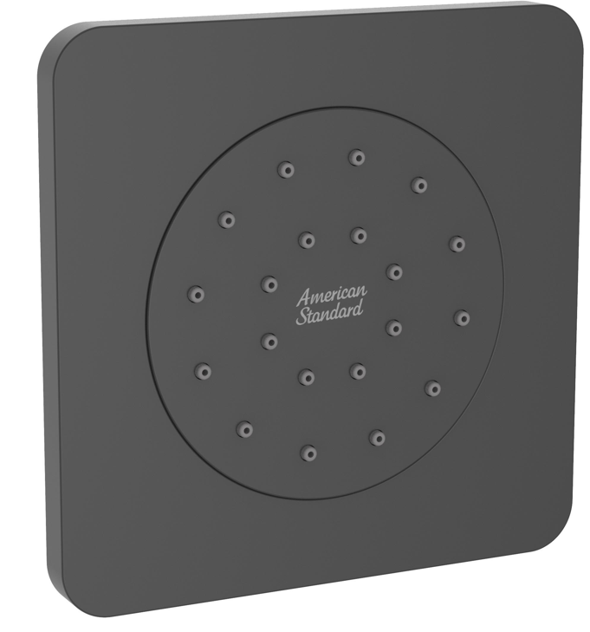

FEATURES

- Plastic escutcheon, Matt Black plated
- Single function
- With constant flow regulator for water saving.
- With normal packaging
- Flow rate @ 0.1MPa: 5.8 L/min

SPECIFICATIONS

Body shower with conceal body

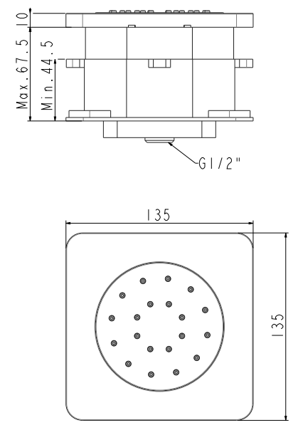
FINISHES AVAILABILITY
DIMENSIONAL DRAWING

Matt Black

AWARDS WON
N/A

SHIPPING WEIGHT
Product gross weight: 0.78 kg
Product Net weight: 0.7kg

STANDARDS CRITERIA
GB/T 23447-2009
Matt Black WI10.0589

This document is the property of American Standard. It can neither be reproduced, nor communicated, without authorization.
American Standard reserves the right to change dimensions and specifications without notice, we assume no liability for the use of obsolete dimensions.

